|  |  |  |  |  |  |  |  |  |  |  |  |  |  |  |  |  |  |  |  |  |  |  |  |  |  |  |  |  |  |  |  |  |  |  |  |  |  |  |  |  |
| --- | --- | --- | --- | --- | --- | --- | --- | --- | --- | --- | --- | --- | --- | --- | --- | --- | --- | --- | --- | --- | --- | --- | --- | --- | --- | --- | --- | --- | --- | --- | --- | --- | --- | --- | --- | --- | --- | --- | --- | --- |
| **华南农业大学数学与信息学院**  **课程设计实验**   |  |  |  |  |  |  |  |  | | --- | --- | --- | --- | --- | --- | --- | --- | | **专业** | 计算机科学与技术 | **班级** | 1班 | **学号** | 202121110110  202116110301 | **姓名** | 林锴  巴云浩 | | **实**  **验**  **题**  **目** | ■设计性 □综合性  基于SSM的教务管理系统 | | | | | | | | **自**  **我**  **评**  **价** | 本次课程设计对我们来说还算比较大的挑战，涉及到数据，界面，逻辑管理，对我们来说是个全新的挑战。整个学习过程中，收获颇丰。通过这次课设学到了很多有关JavaWeb的相关技术，编程能力得到提升，深入学习和掌握了SpringBoot框架，同时小组成员密切合作，培养了与他人团结协作的能力，主要通过git作为项目管理工具进行协作管理。通过这次课设学习到了包括布局管理、图形界面设计、事件处理、控件使用等方面的知识。共同解决了项目中的技术问题和业务需求，这对未来参与团队项目和与他人合作都是非常有价值的。通过这次课设解决问题的能力也得到了提升，在写课设过程中，遇到了很多技术和业务上的困难，如数据库连接池性能问题、前后端交互问题等。 | | | | | | | | **教**  **师**  **评**  **语** | 能够实现实验要求的功能 ☑全部 □部分  算法有新意 ☑有 □一般  程序运行通过 ☑全部 □部分  算法注释说明 ☑完善 □仅有功能说明  接口参数说明 ☑有 □无  按期上交文档资料及源程序 ☑所有 □部分  独立完成实验 ☑能 □不能  体现团队合作精神。 ☑能够 □不能 | | | | | | | | **成绩** |  | | | | | | | |

目录

一、系统概述 1

二、系统分析： 2

2.1项目背景 2

2.2开发平台及开发工具介绍 2

2.3技术架构 3

2.3.1后端 3

2.3.2前端 3

2.3.3数据库 3

三、系统总体框架 4

3.1系统构思 4

3.2系统框架 4

四、数据库结构 6

4.1数据库设计 6

4.2数据库文档 6

4.2.1总表 6

4.2.2班级表 7

4.2.3教室表 7

4.2.4课程列表 7

4.2.5课程表 8

4.2.6学院表 8

4.2.7教学楼表 8

4.2.8学生表 9

4.2.9教师表 9

4.2.10用户表 9

五、系统实现 10

5.1系统总体结构 10

5.2主要模块 12

5.2.1用户登录模块 12

5.2.2系统页面模块 16

5.2.3教室模块 21

5.2.4班级模块 26

5.2.5院系模块 31

5.2.6地点模块 36

5.2.7教工模块 41

5.2.8用户模块 46

5.2.9课程模块 55

5.2.10课程表模块 60

六、总结 68

**基于SSM的教务管理系统**

**一、系统概述**

本作品是一个前后端分离的课程表查询系统，基于SSM（Spring + SpringMVC + MyBatis），拥有信息管理和课表展示功能。

后端使用Spring-boot作为基础，使用thymeleaf（基于Servlet）作为服务器端Java模板引擎。使用SpringMVC（spring内置的MVC框架，底层就是Servlet，它解决WEB开发中常见的问题(参数接收、文件上传、表单验证、国际化等等)，而且使用简单，与Spring无缝集成。支持 RESTful风格的URL请求）解决页面代码和后台代码的分离，降低代码的耦合性。使用mybatis-plus（一个 Mybatis 的增强工具，在 Mybatis 的基础上只做增强不做改变，为简化开发、提高效率而生），已经封装好了一些crud方法，不需要再写xml了，直接调用这些方法就行，就类似于JPA。数据库使用MySQL数据库，数据库数据库连接池使用druid(Druid为监控而生的数据库连接池, 是Java语言中最好的数据库连接池)。使用Lombok在JavaBean中通过添加注解的方式，不需要为类编写getter/setter方法,也不需要编写构造器、equals等方法，同时可以自动化日志变量。同时引用hutool工具包，它能为我们自动生成验证码、格式化日期以及简化JDBC的操作。

前台使用H-ui 前端框架模板，它包含后台基本的增删改查页面，我们只要使用thymeleaf模板引擎循环替换H-UI模板的内容，并且更改静态文件路径，在springMVC的控制器中注册路由并且返回页面就能使用浏览器正常访问。课表的展示使用Timetables.js插件，它通过传入一个二维数组来展示课表，发送ajax请求从服务器获取课程表调用change方法进行展示。

系统能够实现用户的登录退出，教室、班级、院系、地点、教工、学生、用户、课程、课程表的分页展示、增加、删除（批量）、修改、根据条件查询，排课（课程表增删改查）、课程表通过表格展示（可以通过教师、班级、学年、学期进行筛选）。并且使用拦截器通过session判断用户是否登录，未登录用户跳转到登录页面。

**二、系统分析：**

**2.1项目背景**

教务管理系统是一种用于高校、中小学等教育机构管理学生信息、课程安排、成绩录入和查询等教务管理工作的软件系统。随着教育信息化的推进和管理需求的增加，开发一个高效、可靠的教务管理系统变得日益重要。

我们注意到传统的手工处理教务管理事务存在许多问题，如信息不及时，数据容易丢失，工作效率低下等。此外，由于教务管理工作量大、复杂度高，需要同时处理大量的学生数据、课程表、考试成绩等信息，传统的人工处理方式已经无法满足需求。

因此，为了提高教务管理效率、减少人力成本、提供更好的服务质量，我们决定开发一款教务管理系统，以实现以下目标：

1.简化流程：通过系统的自动化流程，简化教务管理过程，减少繁琐的手动操作，提高工作效率。

2.实时信息更新：通过系统自动化处理学生信息、课程表和成绩等数据，确保信息的及时性和准确性，避免手工处理带来的错误和延迟。

3.便捷查询功能：为学生、教师和管理员提供便捷的查询功能，方便他们查找个人档案、课程信息、学生成绩等相关信息。

4.数据安全性：通过建立安全的数据库和权限管理机制，确保学生信息和教务数据的安全性，避免数据泄露和滥用。

**2.2开发平台及开发工具介绍**

**2.2.1开发平台：windows11**

**2.2.2开发工具：**

**IDEA 2023.1.1**

IDEA 全称 IntelliJ IDEA，是 java 编程语言的集成开发环境。IntelliJ 在业界被公认为最好的Java 开发工具，尤其在智能代码助手、代码自动提示、重构、JavaEE 支持、各类版本工具(git、svn等)、JUnit、CVS 整合、代码分析、 创新的 GUI 设计等方面的功能可以说是超常的。

**Visual Studio Code 1.84.0**

Visual Studio Code是一款由微软开发的跨平台集成开发环境（IDE），它具有强大的编辑器功能和丰富的扩展生态系统，适用于各种编程语言和开发需求。VS Code支持智能代码补全、内置调试器、集成终端和Git集成等特性，同时具有快速启动和轻量级的优势，成为众多开发人员喜爱的工具之一。无论是软件开发还是Web开发，VS Code都提供了高效、灵活和易用的开发环境，帮助开发者提升编码效率和开发质量。

**Navicat Premium 16**

Navicat Premium 16是一款集成多种数据库管理工具的软件，支持MySQL、Oracle、SQL Server等主流数据库系统。它提供了直观的用户界面和强大的功能，包括数据可视化、数据同步、备份与恢复、数据转移、数据建模等，让用户在管理和开发数据库的过程中变得更加高效和便捷。

**2.3技术架构**

**2.3.1后端**

主要开发框架：SpringBoot2.6.1 + MyBatis-Plus3.4.3

开发语言：Java JDK8

开发技术：JavaEE开发技术，SpeingMVC架构技术，SpringBoot开发技术，Mybatis-plus代码生成技术，Mybatis-plus分页技术，Mybatis-plus查询技术，Lombok注解开发技术，Durid数据库连接池技术，screw数据库文档生成技术，Kaptcha验证码技术，thymeleaf模块引擎技术，Timetable课程表展示技术，Git版本控制技术

**2.3.2前端**

前端开发框架：H-ui 3.1(基于bootStrap框架+JQuery库)

开发语言：HTML+CSS+JavaScript

开发技术：JavaScript交互技术，axios技术，ajax异步请求技术，路由交互技术，

session拦截技术

**2.3.3数据库**

开发语言：MySQL 8.0.33

开发工具 Navicat Premium 16

**三、系统总体框架**

**3.1系统构思**

教务管理系统采用了SSM（Spring + SpringMVC + MyBatis）的基础架构。后端使用Maven 进行包管理，使用Spring-Boot框架、模板引擎使用Thymeleaf、web模块使用SpringMVC、数据库连接池使用Druid、数据库访问使用Mybatis-plus、工具包使用Hutool。前端使用H-ui模板，结合Timetables展示课程表。系统能够实现用户的登录退出，教室、班级、院系、地点、教工、学生、用户、课程、课程表的分页展示、增加、删除（批量）、修改、根据条件查询，排课（课程表增删改查）、课程表通过表格展示（可以通过教师、班级、学年、学期进行筛选）。并且使用拦截器通过session判断用户是否登录。

**3.2系统框架**

本作品整体结构如图1所示。实现用户的登录退出，教室、班级、院系、地点、教工、学生、用户、课程、课程表的分页展示、增加、删除（批量）、修改、根据条件查询，排课（课程表增删改查）、课程表通过表格展示（可以通过教师、班级、学年、学期进行筛选）。并且使用拦截器通过session判断用户是否登录，未登录用户跳转到登录页面。

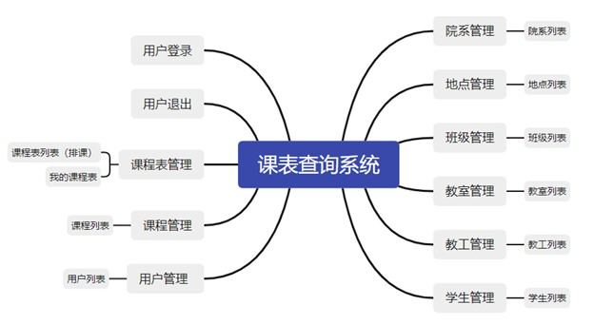

**图1 系统总体架构**

系统用户类型分为：管理员、教师、学生。

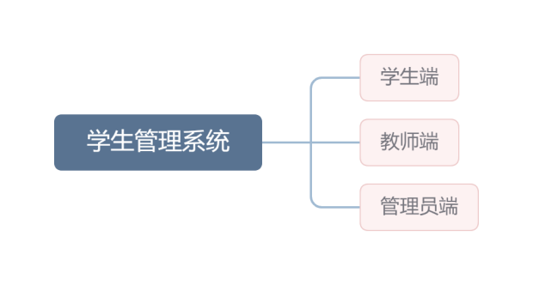

**图2 用户类型**

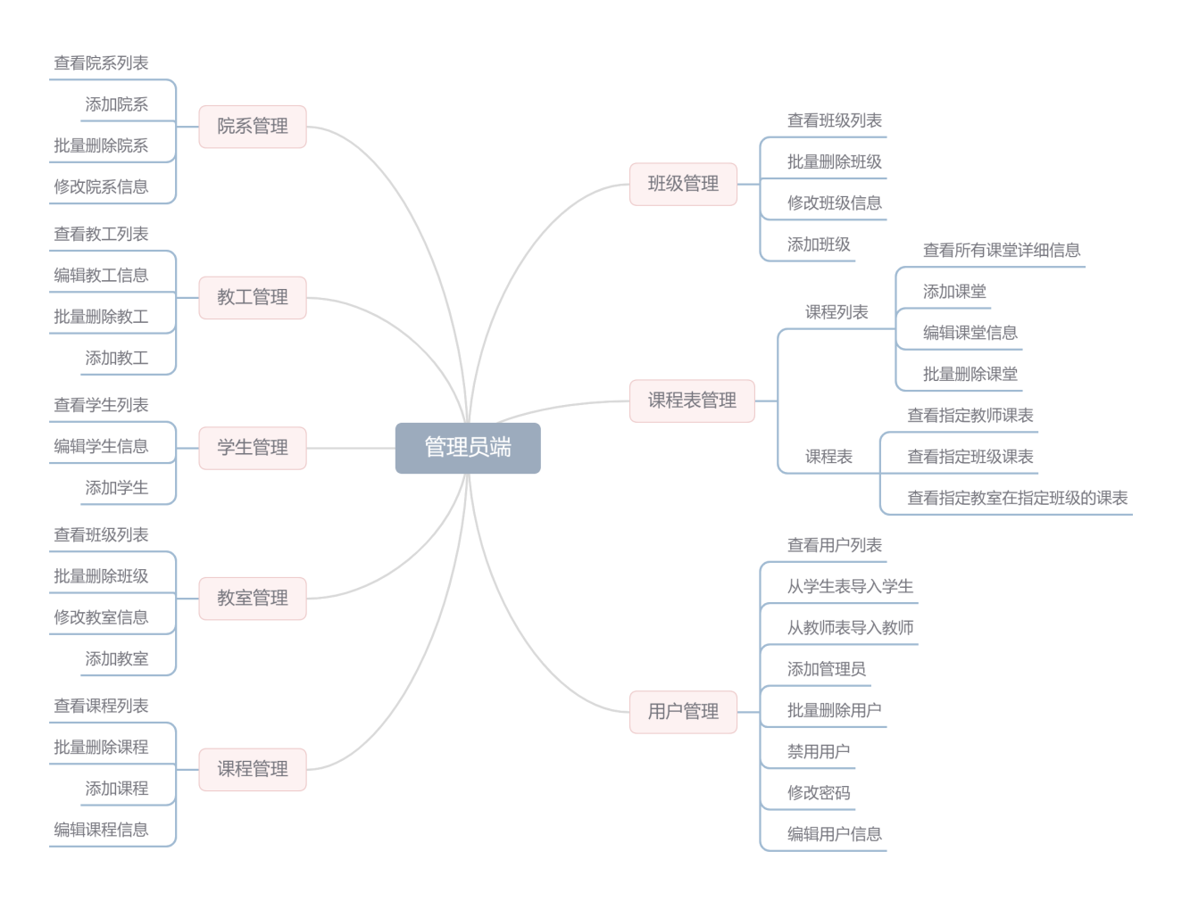

**图3 管理员端**

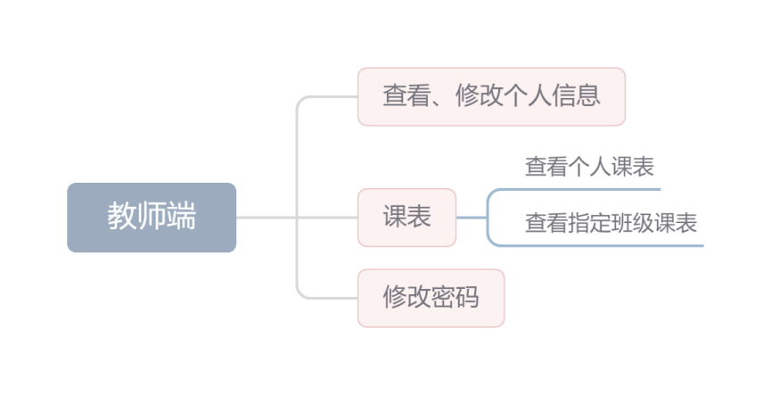

**图4 教师端**

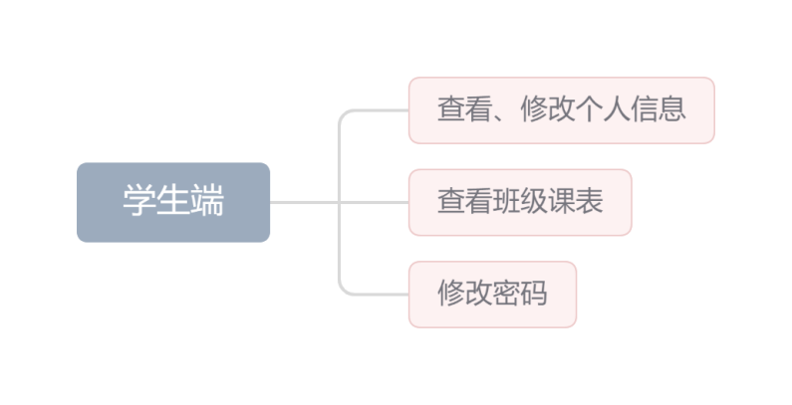

**图5 学生端**

**四、数据库结构**

**4.1数据库设计**

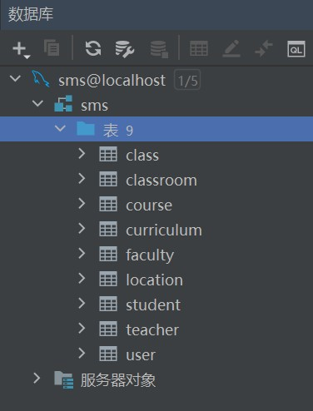

**图6 数据库总体框架图**

本课程表系统包含9张表名称如图6所示。数据表设计按照第一范式设计，要求字段是对属性的原子性约束，要求属性具有原子性，不可再分解。

**4.2数据库文档**

**数据库名：**sms

**文档版本：**1.0.0

**文档描述：**数据库设计文档生成

**4.2.1总表**

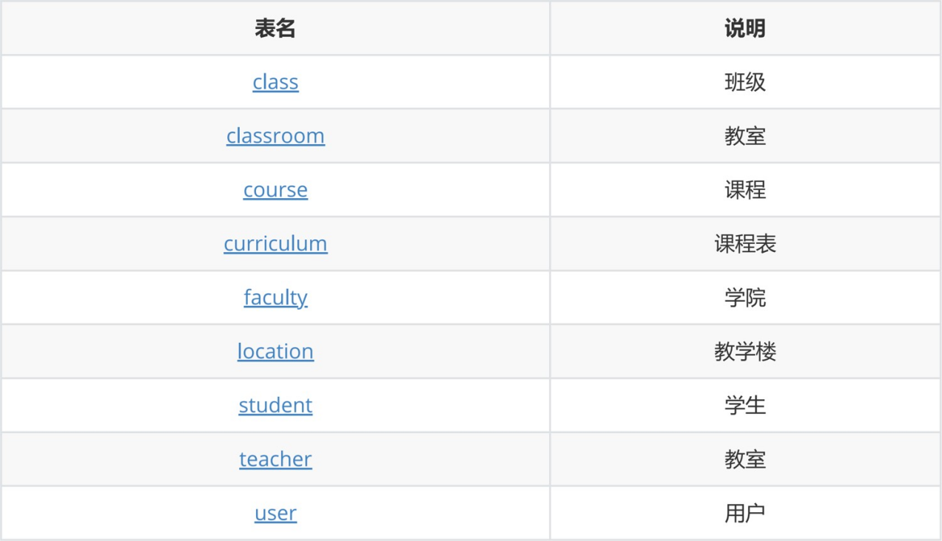

**图7 数据库总表**

**4.2.2班级表**

**表名：**class

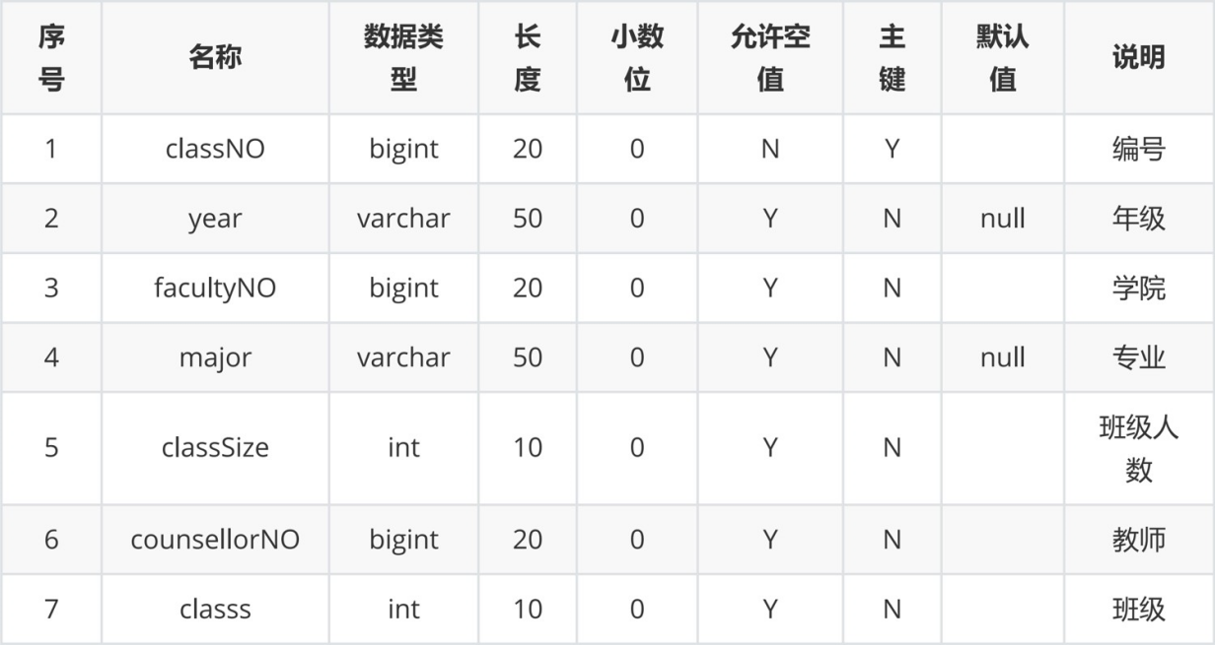

**图8 班级表**

**4.2.3教室表**

**表名：**classroom

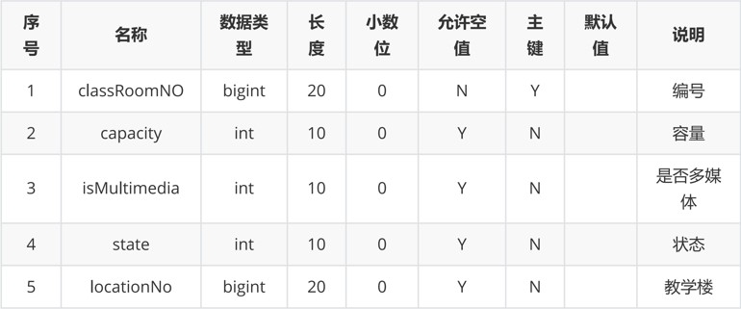

**图9 教室表**

**4.2.4课程列表**

**表名：**course

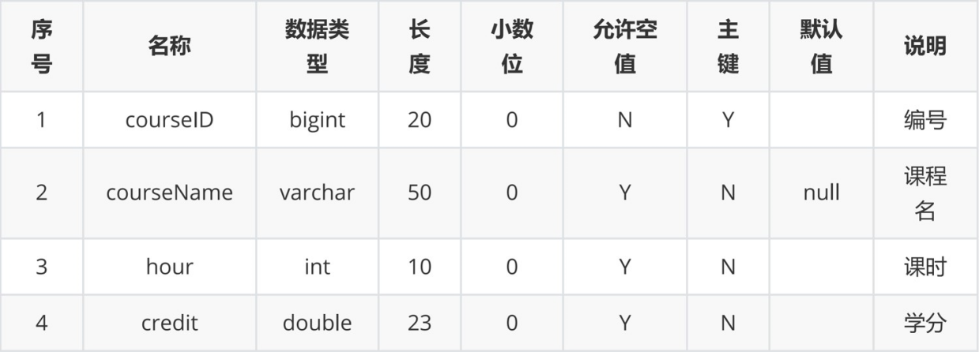

**图10 课程列表**

**4.2.5课程表**

**表名：**curriculum

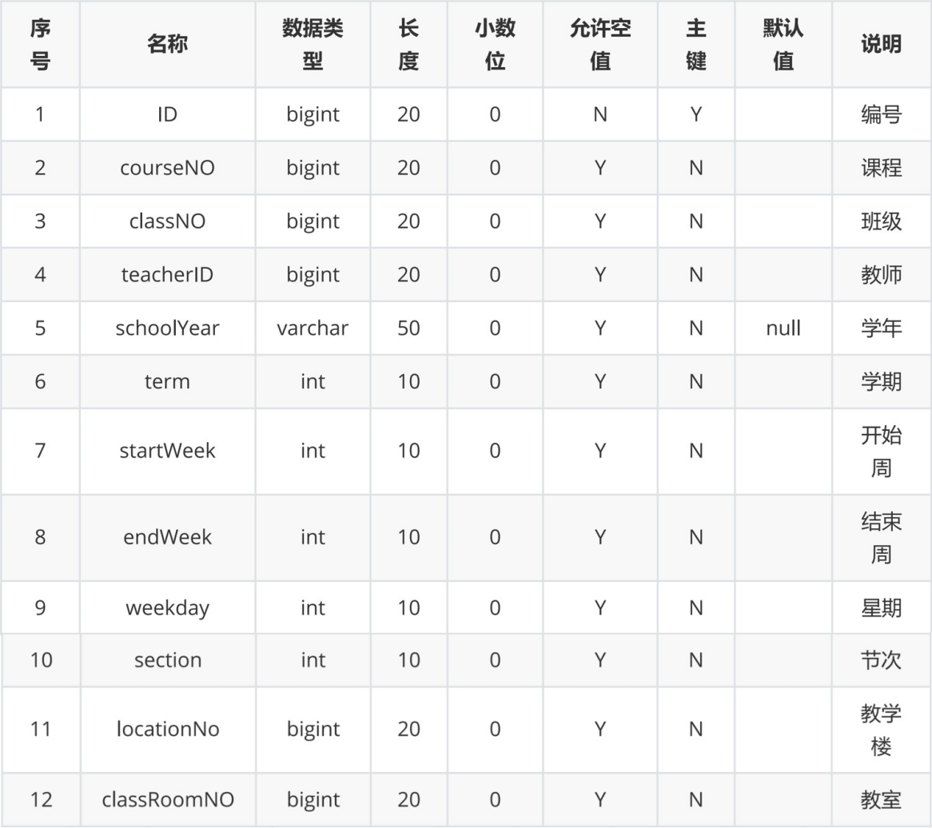

**图11 课程表**

**4.2.6学院表**

**表名：**faculty

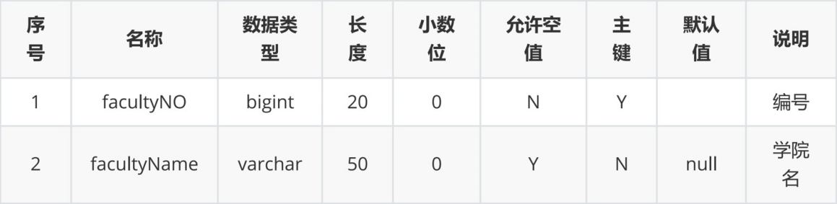

**图12 学院表**

**4.2.7教学楼表**

**表名：**location

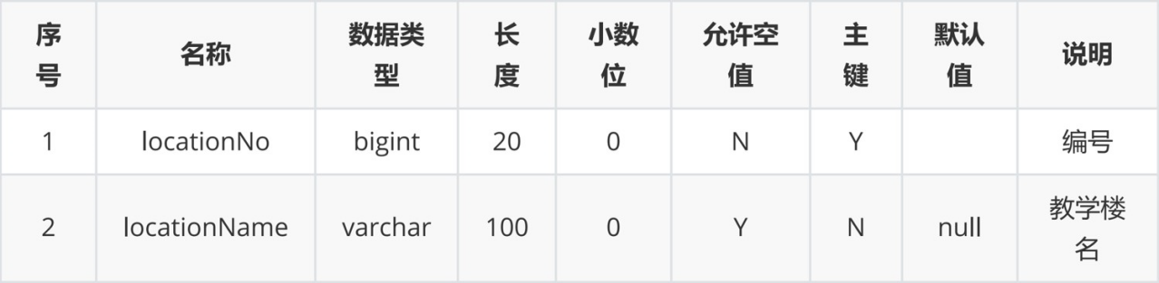

**图13 教学楼表**

**4.2.8学生表**

**表名：**student

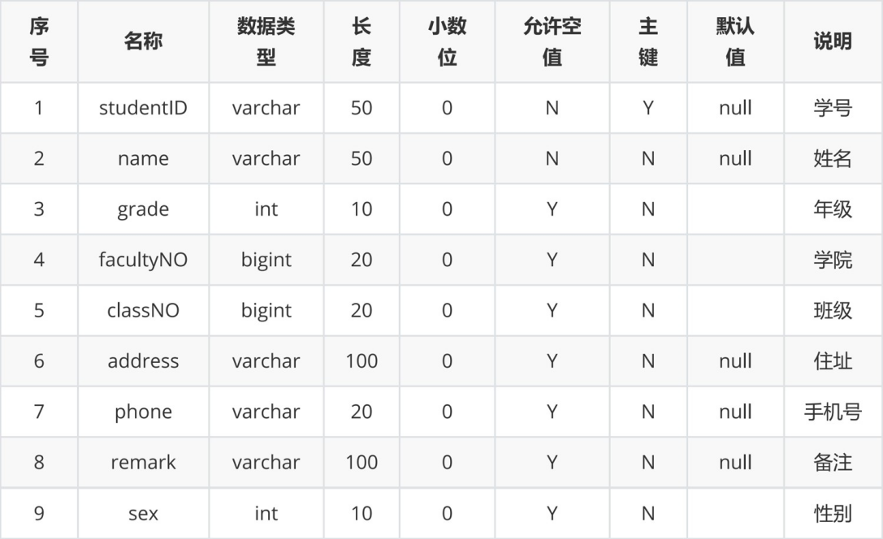

**图14 学生表**

**4.2.9教师表**

**表名：**teacher

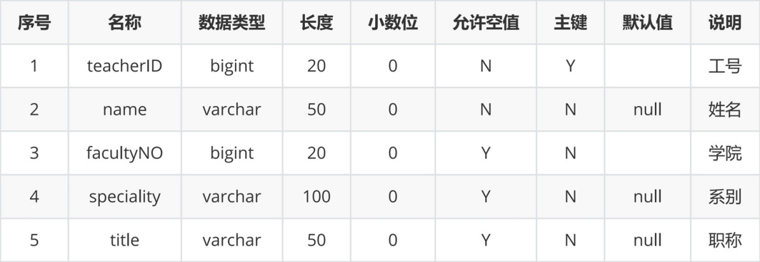

**图15 教师表**

**4.2.10用户表**

**表名：**user

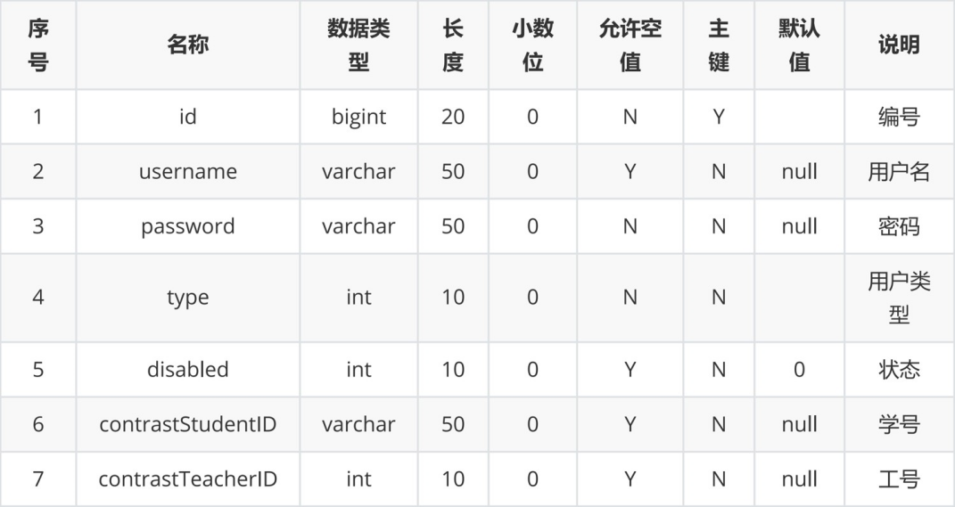

**图16 用户表**

**五、系统实现**

**5.1系统总体结构**

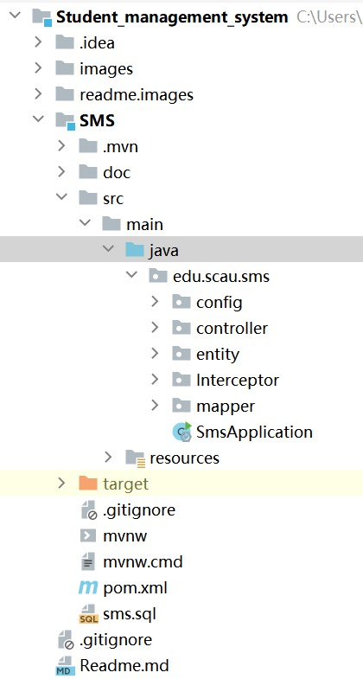

**图17 项目结构图**

本程序有 6 个包：config（配置包）、controller（控制器层）、entity（实体包）、Interceptor（拦截器包）、mapper（数据库访问层）、resources（前端模板资源）。

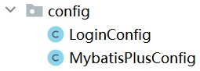

**图18 config**

在config中，包含SpringMVC配置与Mybatis-plus配置。

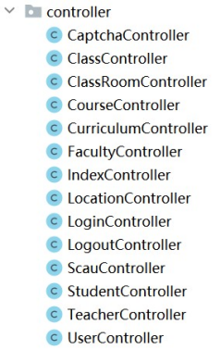

**图19 controller**

在controller层中，包含验证码控制器、班级控制器、教室控制器、课程控制器、课程表控制器、学院控制器、首页控制器、教学楼控制器、登入登出控制器、原神界面控制器、学生控制器、教师控制器、用户控制器。

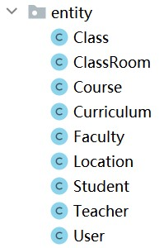

**图20 entity**

在entity层中，包含班级实体类、教室实体类、课程实体类、课程表实体类、学院实体类、教学楼实体类、学生实体类、教师实体类、用户实体类。

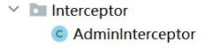

**图21 Interceptor**

在Interceptor层中，包含拦截器，拦截和权限验证。

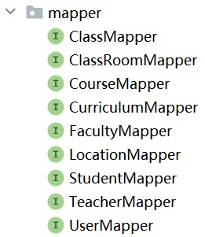

**图22 mapper**

在mapper层中，包含各种类的Mapper和DAO。

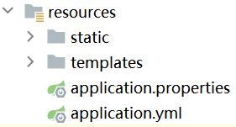

**图23 resources**

在resources包中，包含static（前端静态资源库）、templates（thymeleaf模板路径）、application.properties（Springboot配置文件）、application.yml（yaml配置文件）。

**5.2主要模块**

**5.2.1用户登录模块**

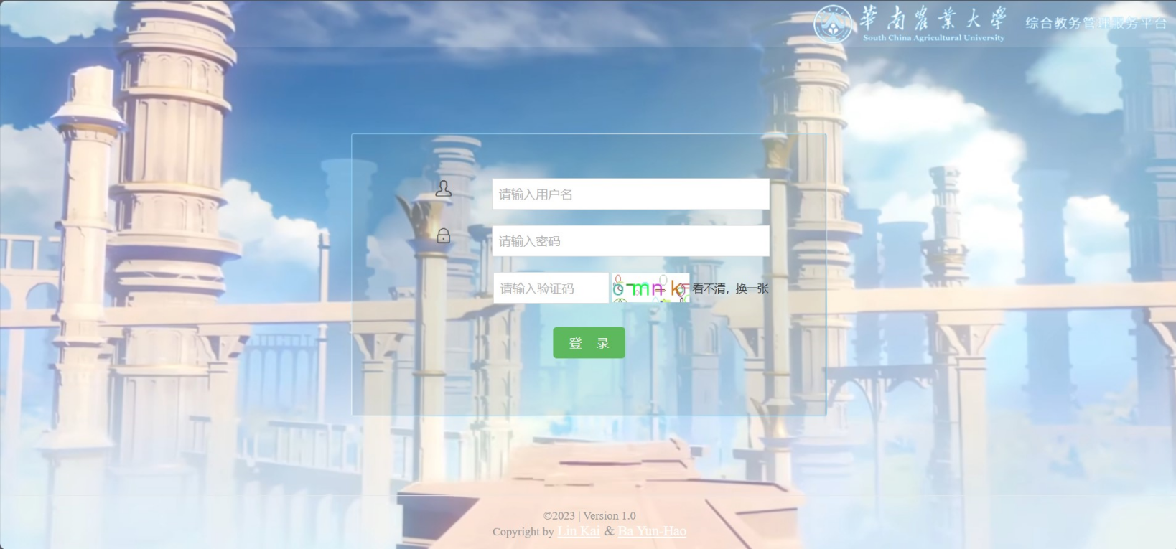**图24 用户登录**

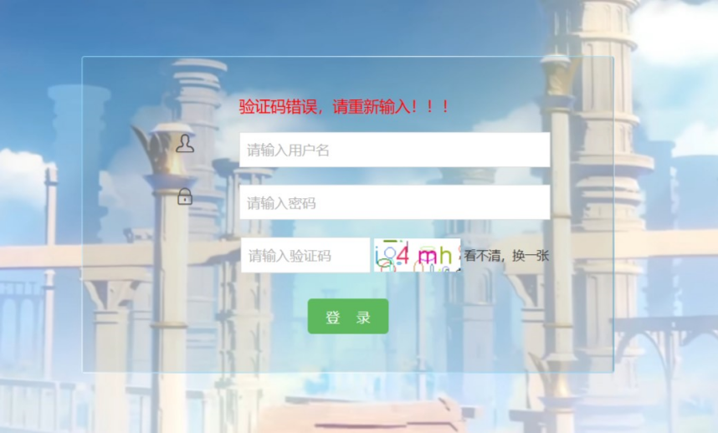

**图25 验证码错误**

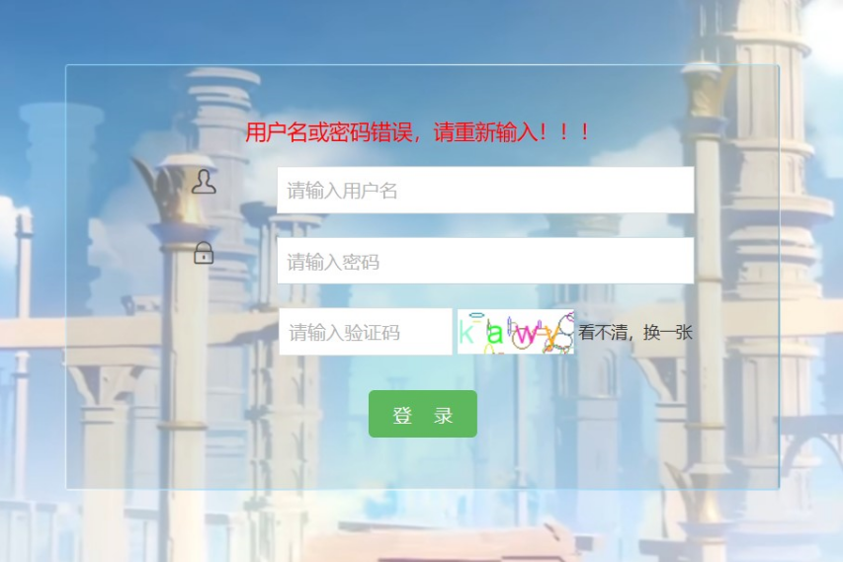

**图26 用户名或密码错误**

LoginController.java

@Slf4j  
@Controller  
public class LoginController {  
 @Autowired  
 private UserMapper userMapper;  
  
 @Autowired  
 private StudentController studentController;  
  
 @Autowired  
 private TeacherController teacherController;  
  
 @GetMapping("/login")  
 public String toLogin(){  
 return "login";  
 }  
  
 @PostMapping("/login")  
 public String login(User user, HttpSession httpSession, Model model){  
 *log*.info(String.*valueOf*(user));  
*// 验证码是否匹配* if (user.getCaptcha().equalsIgnoreCase((String) httpSession.getAttribute("SESSION_KEY_IMAGE_CODE"))) {  
*// 用户是否存在* QueryWrapper<User> userQueryWrapper = new QueryWrapper<>();  
 userQueryWrapper.eq("username", user.getUsername());  
 User u1 = userMapper.selectOne(userQueryWrapper);  
 *log*.info(String.*valueOf*(u1));  
 if (u1 != null){  
 *// 用户存在 判断密码是否一致* if (u1.getPassword().equals(user.getPassword())){  
 if (u1.getDisabled()==0){  
 model.addAttribute("info","登录成功！！！");  
 User u = userMapper.selectOne(new QueryWrapper<User>().eq("username",user.getUsername()));  
 u.setPassword("******");  
 if (u.getContrastStudentID()!=null){  
 Student student = studentController.getStudentById(u.getContrastStudentID());  
 u.setClassNO(student.getClassNO());  
 u.setContrastStudentName(student.getName());  
 }  
 if (u.getContrastTeacherID()!=null){  
 Teacher teacher = teacherController.getTeacherById(u.getContrastTeacherID());  
 u.setContrastTeacherName(teacher.getName());  
 }  
 httpSession.setAttribute("USER",u);  
 return "redirect:index";  
 } else {  
 model.addAttribute("info","用户已被禁用，请联系管理员！！！");  
 return "login";  
 }  
 } else {  
 model.addAttribute("info","用户名或密码错误，请重新输入！！！");  
 return "login";  
 }  
 } else {  
*// 用户不存在* model.addAttribute("info","该用户不存在，请重新输入！！！");  
 return "login";  
 }  
 } else {  
 model.addAttribute("info","验证码错误，请重新输入！！！");  
 return "login";  
 }  
 }  
}

CaptchaController.java 验证码控制器

@Controller  
@Slf4j  
public class CaptchaController {  
 public final static String *SESSION_KEY_IMAGE_CODE* = "SESSION_KEY_IMAGE_CODE";  
  
 @GetMapping("/captcha")  
 public void createCode(HttpServletRequest request, HttpServletResponse response) throws IOException {  
 *//设置response响应* response.setCharacterEncoding("UTF-8");  
 response.setHeader("Pragma", "No-cache");  
 response.setHeader("Cache-Control", "no-cache");  
 response.setDateHeader("Expires", 0);  
 response.setContentType("image/jpeg");  
  
 *//定义图形验证码的长、宽、验证码字符数、干扰元素个数* CircleCaptcha captcha = CaptchaUtil.*createCircleCaptcha*(100, 38, 4, 20);  
 System.*out*.println(captcha.getCode());  
 *//将验证码放到HttpSession里面* request.getSession().setAttribute(*SESSION_KEY_IMAGE_CODE*, captcha.getCode());  
 *log*.info("本次生成的验证码为：" + captcha.getCode() + ",已存放到HttpSession中");  
  
 *//图形验证码写出，可以写出到文件，也可以写出到流  
 //输出浏览器* OutputStream out = response.getOutputStream();  
 captcha.write(out);  
 out.flush();  
 out.close();  
 }  
}

**5.2.2系统页面模块**

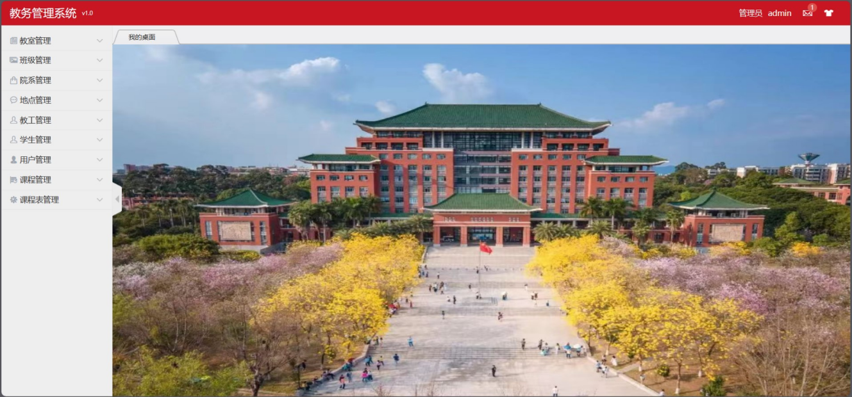**图27 管理员用户首页**

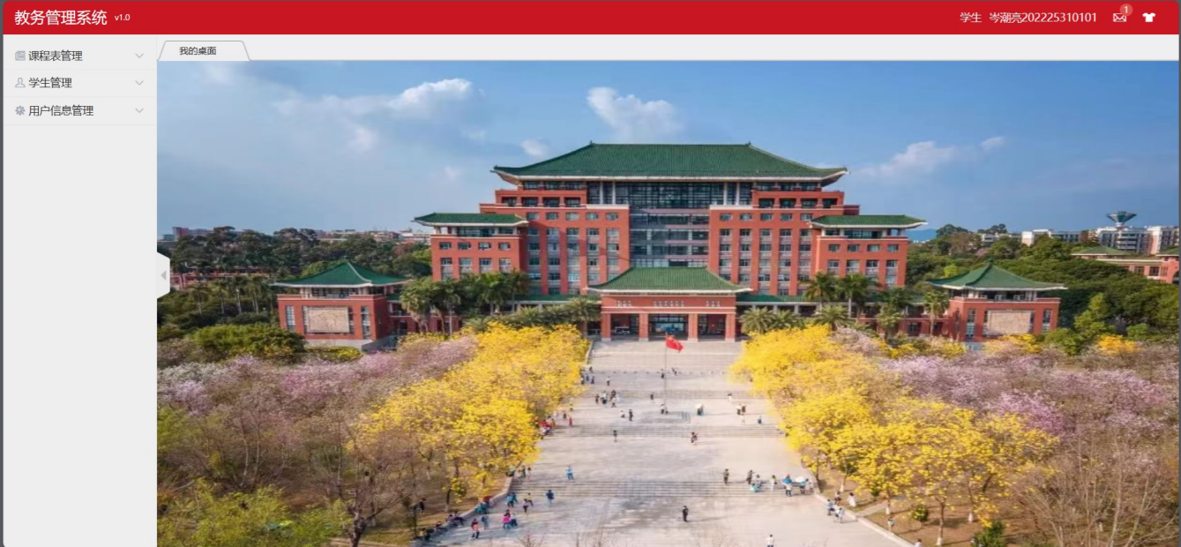**图28 学生用户首页**

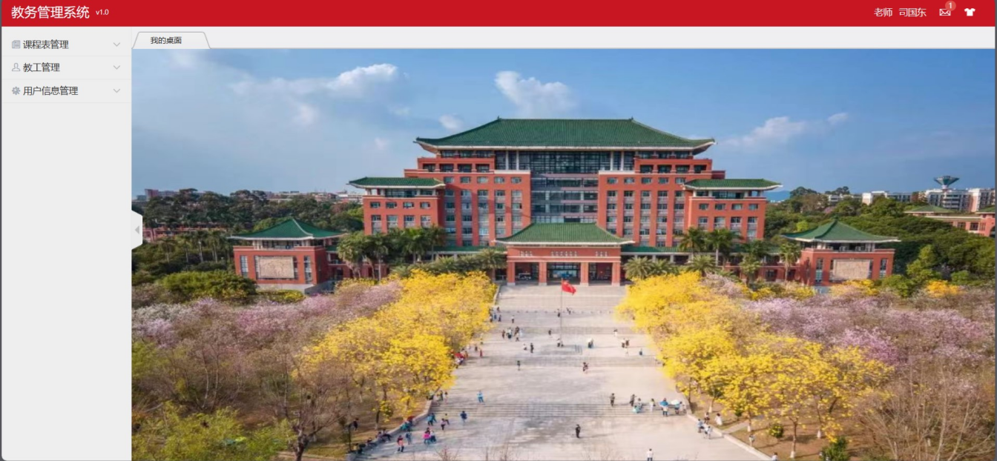**图29 教师用户首页**

Indext.html 部分代码

<aside class="Hui-aside">  
 <div th:if="${session.USER.type==2}" class="menu_dropdown bk_2">  
 <dl id="menu-article">  
 <dt><i class="Hui-iconfont">&#xe616;</i> 教室管理<i class="Hui-iconfont menu_dropdown-arrow">&#xe6d5;</i></dt>  
 <dd>  
 <ul>  
 <li><a th:data-href="@{/classRoom/classRoomListPage}" data-title="教室列表" href="javascript:void(0)">教室列表</a></li>  
 </ul>  
 </dd>  
 </dl>  
 <dl id="menu-picture">  
 <dt><i class="Hui-iconfont">&#xe613;</i> 班级管理<i class="Hui-iconfont menu_dropdown-arrow">&#xe6d5;</i></dt>  
 <dd>  
 <ul>  
 <li><a th:data-href="@{/class/classListPage}" data-title="班级列表" href="javascript:void(0)">班级列表</a></li>  
 </ul>  
 </dd>  
 </dl>  
 <dl id="menu-product">  
 <dt><i class="Hui-iconfont">&#xe620;</i> 院系管理<i class="Hui-iconfont menu_dropdown-arrow">&#xe6d5;</i></dt>  
 <dd>  
 <ul>  
 <li><a th:data-href="@{/faculty/facultyListPage}" data-title="院系列表" href="javascript:void(0)">院系列表</a></li>  
 </ul>  
 </dd>  
 </dl>  
 <dl id="menu-comments">  
 <dt><i class="Hui-iconfont">&#xe622;</i> 地点管理<i class="Hui-iconfont menu_dropdown-arrow">&#xe6d5;</i></dt>  
 <dd>  
 <ul>  
 <li><a th:data-href="@{/location/locationListPage}" data-title="地点列表" href="javascript:;">地点列表</a></li>  
 </ul>  
 </dd>  
 </dl>  
 <dl id="menu-teacher">  
 <dt><i class="Hui-iconfont">&#xe60d;</i> 教工管理<i class="Hui-iconfont menu_dropdown-arrow">&#xe6d5;</i></dt>  
 <dd>  
 <ul>  
 <li><a th:data-href="@{/teacher/teacherListPage}" data-title="教工列表" href="javascript:;">教工列表</a></li>  
 </ul>  
 </dd>  
 </dl>  
 <dl id="menu-student">  
 <dt><i class="Hui-iconfont">&#xe60d;</i> 学生管理<i class="Hui-iconfont menu_dropdown-arrow">&#xe6d5;</i></dt>  
 <dd>  
 <ul>  
 <li><a th:data-href="@{/student/studentListPage}" data-title="学生列表" href="javascript:;">学生列表</a></li>  
 </ul>  
 </dd>  
 </dl>  
 <dl id="menu-admin">  
 <dt><i class="Hui-iconfont">&#xe62d;</i> 用户管理<i class="Hui-iconfont menu_dropdown-arrow">&#xe6d5;</i></dt>  
 <dd>  
 <ul>  
 <li><a th:data-href="@{/user/userListPage}" data-title="用户列表" href="javascript:void(0)">用户列表</a></li>  
 </ul>  
 </dd>  
 </dl>  
 <dl id="menu-tongji">  
 <dt><i class="Hui-iconfont">&#xe61a;</i> 课程管理<i class="Hui-iconfont menu_dropdown-arrow">&#xe6d5;</i></dt>  
 <dd>  
 <ul>  
 <li><a th:data-href="@{/course/courseListPage}" data-title="课程列表" href="javascript:void(0)">课程列表</a></li>  
 </ul>  
 </dd>  
 </dl>  
 <dl id="menu-system">  
 <dt><i class="Hui-iconfont">&#xe62e;</i> 课程表管理<i class="Hui-iconfont menu_dropdown-arrow">&#xe6d5;</i></dt>  
 <dd>  
 <ul>  
 <li><a th:data-href="@{/curriculum/curriculumListPage}" data-title="课程表列表" href="javascript:void(0)">课程表列表</a></li>  
 <li><a th:data-href="@{/curriculum/myCurriculumPage}" data-title="我的课程表" href="javascript:void(0)">我的课程表</a></li>  
 </ul>  
 </dd>  
 </dl>  
 </div>  
 <div th:if="${session.USER.type!=2}" class="menu_dropdown bk_2">  
 <dl id="menu-article2">  
 <dt><i class="Hui-iconfont">&#xe616;</i> 课程表管理<i class="Hui-iconfont menu_dropdown-arrow">&#xe6d5;</i></dt>  
 <dd>  
 <ul>  
 <li><a th:data-href="@{/curriculum/myCurriculumPage}" data-title="我的课程表" href="javascript:void(0)">我的课程表</a></li>  
 </ul>  
 </dd>  
 </dl>  
 <dl th:if="${session.USER.type==1}" id="menu-teacher2">  
 <dt><i class="Hui-iconfont">&#xe60d;</i> 教工管理<i class="Hui-iconfont menu_dropdown-arrow">&#xe6d5;</i></dt>  
 <dd>  
 <ul>  
 <li><a th:data-href="@{/teacher/teacherPage?teacherID=}+${session.USER.contrastTeacherID}" data-title="教工列表" href="javascript:;">教工列表</a></li>  
 </ul>  
 </dd>  
 </dl>  
 <dl th:if="${session.USER.type==0}" id="menu-student2">  
 <dt><i class="Hui-iconfont">&#xe60d;</i> 学生管理<i class="Hui-iconfont menu_dropdown-arrow">&#xe6d5;</i></dt>  
 <dd>  
 <ul>  
 <li><a th:data-href="@{/student/studentPage?studentID=}+${session.USER.contrastStudentID}" data-title="学生列表" href="javascript:;">学生列表</a></li>  
 </ul>  
 </dd>  
 </dl>  
 <dl id="menu-system2">  
 <dt><i class="Hui-iconfont">&#xe62e;</i> 用户信息管理<i class="Hui-iconfont menu_dropdown-arrow">&#xe6d5;</i></dt>  
 <dd>  
 <ul>  
 <li><a th:data-href="@{/user/userPage?username=}+${session.USER.username}" data-title="用户信息" href="javascript:void(0)">用户信息</a></li>  
 </ul>  
 </dd>  
 </dl>  
 </div>  
</aside>

IndexController.java 首页控制器

@Controller  
public class IndexController {  
 @GetMapping(value = {"/","/index"})  
 public String index(){  
 return "index";  
 }  
  
 @GetMapping("/welcome")  
 public String welcome(){  
 return "welcome";  
 }  
}

LogoutController.java 用户退出登录

@Controller  
public class LogoutController {  
 @GetMapping("/logout")  
 public String logout(HttpSession session){  
 session.removeAttribute("USER");  
 return "login";  
 }  
}

**5.2.3教室模块**

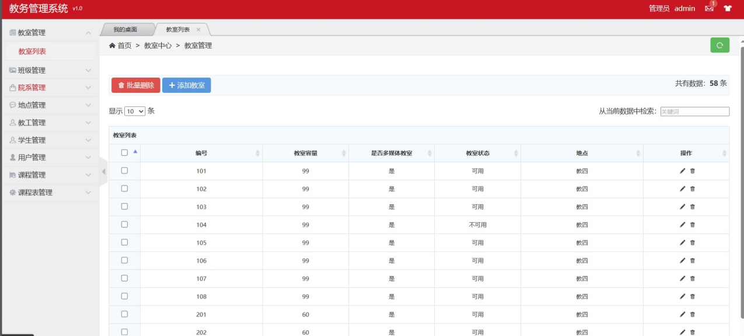**图30 教室分页列表页面**

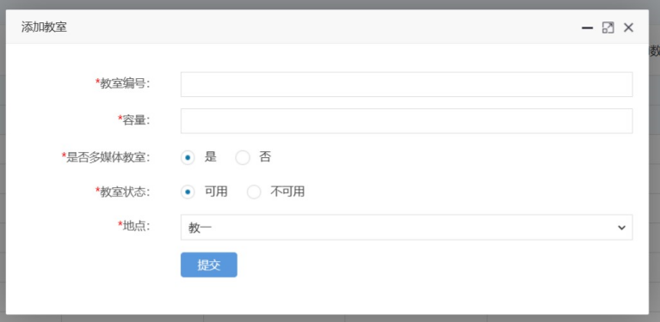

**图31 添加教室**

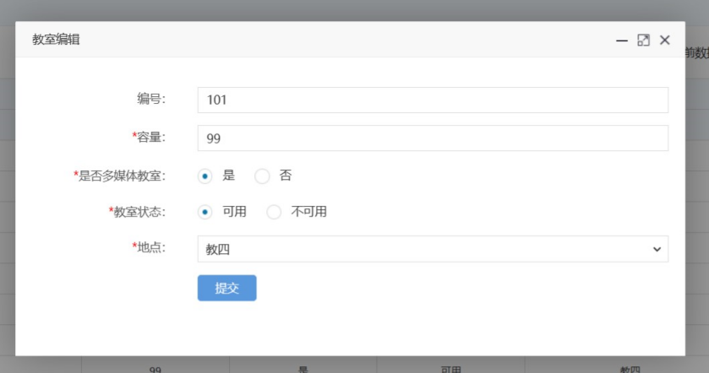

**图32 编辑教室**

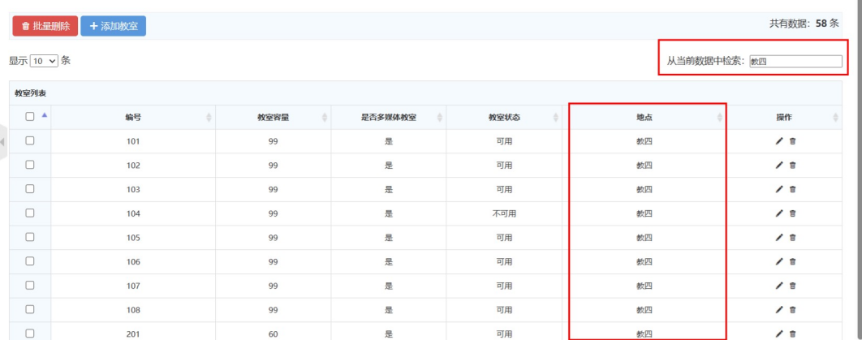

**图33 通过条件查询教室**

ClassRoom.java 教室实体类

@Data  
@NoArgsConstructor  
@AllArgsConstructor  
@TableName("classroom")  
public class ClassRoom implements Serializable {  
 @TableId  
 private Integer classRoomNO; *// 教室编号* private Integer capacity; *// 容量* private Integer isMultimedia; *// 是否多媒体教室* private Integer state; *// 教室状态* private Integer locationNo; *// 地点* @TableField(exist = false)  
 private String locationName; *//验证码*}

ClassRoomMapper.java 教室Mapper和Dao

@Repository  
public interface ClassRoomMapper extends BaseMapper<ClassRoom> {  
}

ClassRoomController.java 教室控制器

@Slf4j  
@Controller  
public class ClassRoomController {  
 @Autowired  
 private ClassRoomMapper classRoomMapper;  
  
 @Autowired  
 private LocationController locationController;  
  
 @ResponseBody  
 @GetMapping("/classRoom/isAvailableClassRoomNO")  
 public HashMap<String, Object> isAvailableClassRoomNO(ClassRoom classRoom){  
 ClassRoom room = classRoomMapper.selectById(classRoom.getClassRoomNO());  
 HashMap<String, Object> map = new HashMap<>();  
 if (room == null){  
 map.put("code","100");  
 map.put("id",classRoom.getClassRoomNO());  
 } else {  
 map.put("code","500");  
 map.put("id",classRoom.getClassRoomNO());  
 }  
 return map;  
 }  
  
 @ResponseBody  
 @GetMapping("/classRoom/classRoomList")  
 public List<ClassRoom> toClassRoomList(){  
 return classRoomMapper.selectList(null);  
 }  
  
 public ClassRoom getClassRoomById(Integer id){  
 return classRoomMapper.selectById(id);  
 }  
   
   
 @GetMapping("/classRoom/classRoomListPage")  
 public String toClassRoomList(Model model){  
 List<ClassRoom> classRoomList = classRoomMapper.selectList(null);  
 for (ClassRoom classRoom : classRoomList) {  
 classRoom.setLocationName(locationController.getLocationById(classRoom.getLocationNo()).getLocationName());  
 }  
 model.addAttribute("classRoomList",classRoomList);  
 return "classRoom/admin-list";  
 }  
  
 @ResponseBody  
 @PostMapping("/classRoom/deleteClassRoomById")  
 public HashMap<String, Object> deleteClassRoomById(ClassRoom classRoom){  
 *log*.info(classRoom.toString());  
  
 int count = classRoomMapper.deleteById(classRoom.getClassRoomNO());  
 *log*.info(String.*valueOf*(count));  
  
 HashMap<String, Object> map = new HashMap<>();  
 if (count==1){  
 map.put("code","100");  
 map.put("id",classRoom.getClassRoomNO());  
 } else {  
 map.put("code","500");  
 map.put("id",classRoom.getClassRoomNO());  
 }  
 return map;  
 }  
  
 @ResponseBody  
 @PostMapping("/classRoom/deleteBatchIds")  
 public HashMap<String, Object> deleteBatchIds(String ids){  
 System.*out*.println(ids);  
  
 JSON parse = JSONUtil.*parse*(ids);  
 int count = classRoomMapper.deleteBatchIds((Collection<? extends Serializable>) parse);  
 *log*.info(String.*valueOf*(count));  
 HashMap<String, Object> map = new HashMap<>();  
 if (count>=1){  
 map.put("code","100");  
 map.put("ids",ids);  
 } else {  
 map.put("code","500");  
 map.put("ids",ids);  
 }  
 return map;  
 }  
  
 @GetMapping("/classRoom/classRoomAdd")  
 public String toUserAdd(Model model){  
 List<Location> locations = locationController.locationList();  
 model.addAttribute("locationList",locations);  
 return "classRoom/admin-add";  
 }  
  
 @ResponseBody  
 @PostMapping("/classRoom/classRoomAdd")  
 public HashMap<String, Object> classRoomAdd(ClassRoom classRoom){  
 *log*.info(classRoom.toString());  
  
 int count = classRoomMapper.insert(classRoom);  
 *log*.info(String.*valueOf*(count));  
  
 HashMap<String, Object> map = new HashMap<>();  
 if (count==1){  
 map.put("code","100");  
 map.put("id",classRoom.getClassRoomNO());  
 } else {  
 map.put("code","500");  
 map.put("id",classRoom.getClassRoomNO());  
 }  
 return map;  
 }  
  
 @GetMapping("/classRoom/classRoomUpdate/{id}")  
 public String toClassRoomUpdate(@PathVariable("id") Integer id, Model model){  
 List<Location> locations = locationController.locationList();  
 model.addAttribute("locationList",locations);  
 ClassRoom t = classRoomMapper.selectById(id);  
 model.addAttribute("classRoom",t);  
 return "classRoom/admin-update";  
 }  
  
 @ResponseBody  
 @PostMapping("/classRoom/classRoomUpdate")  
 public HashMap<String, Object> classRoomUpdate(ClassRoom classRoom){  
 *log*.info(classRoom.toString());  
  
 int count = classRoomMapper.updateById(classRoom);  
 *log*.info(String.*valueOf*(count));  
  
 HashMap<String, Object> map = new HashMap<>();  
 if (count==1){  
 map.put("code","100");  
 map.put("id",classRoom.getClassRoomNO());  
 } else {  
 map.put("code","500");  
 map.put("id",classRoom.getClassRoomNO());  
 }  
 return map;  
 }  
}

**5.2.4班级模块**

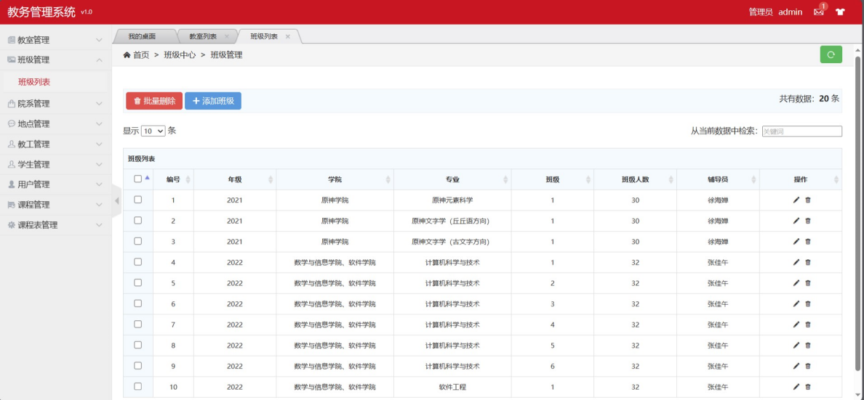

**图34 班级分页列表页面**

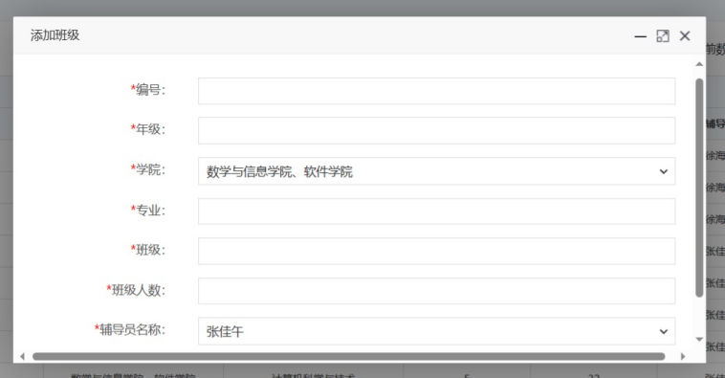

**图35 添加班级**

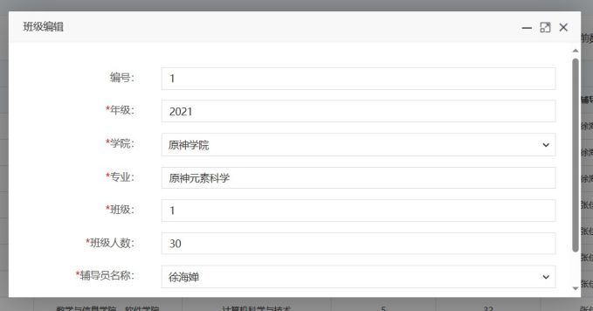

**图36 编辑班级**

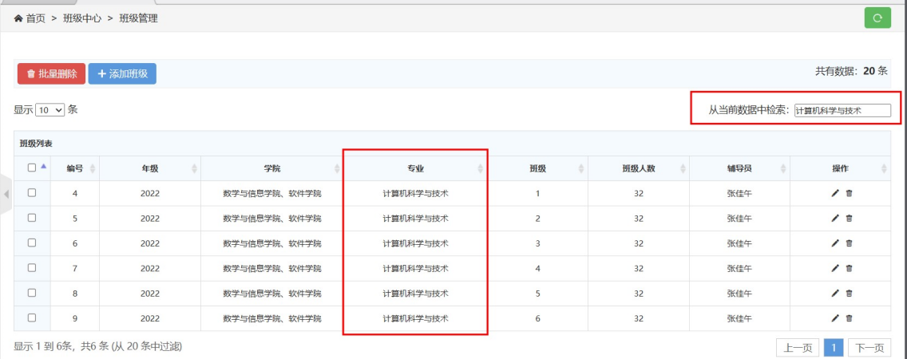

**图37 通过条件查询班级**

Class.java 班级实体类

@Data  
@NoArgsConstructor  
@AllArgsConstructor  
@TableName("class")  
public class Class implements Serializable {  
 @TableId  
 private Integer classNO; *//班号* private Integer facultyNO; *//院系* @TableField(exist = false)  
 private String facultyName; *//院系名称* private Integer classSize; *// 班级人数  
// @DateTimeFormat(pattern = "yyyy-MM-dd")* private Integer year; *// 入学年份* private Integer counsellorNO; *// 辅导员* private String major;  
 private Integer classs;  
 @TableField(exist = false)  
 private String counsellorName; *//辅导员名称*}

ClassMapper.java 班级mapper和Dao

@Repository  
public interface ClassMapper extends BaseMapper<Class> {  
}

ClassController.java 班级控制器

@Slf4j  
@Controller  
public class ClassController {  
 @Autowired  
 private ClassMapper classMapper;  
  
 @Autowired  
 private FacultyController facultyController;  
  
 @Autowired  
 private TeacherController teacherController;  
  
 @ResponseBody  
 @GetMapping("/class/isAvailableClassNO")  
 public HashMap<String, Object> isAvailableID(Class classes){  
 Class aClass = classMapper.selectById(classes.getClassNO());  
 HashMap<String, Object> map = new HashMap<>();  
 if (aClass == null){  
 map.put("code","100");  
 map.put("id",classes.getClassNO());  
 } else {  
 map.put("code","500");  
 map.put("id",classes.getClassNO());  
 }  
 return map;  
 }  
  
 @ResponseBody  
 @GetMapping("/class/classList")  
 public List<Class> toClassList(){  
 return classMapper.selectList(null);  
 }  
  
 public Class getClassById(Integer id){  
 return classMapper.selectById(id);  
 }  
  
 @GetMapping("/class/classListPage")  
 public String toClassList(Model model){  
 List<Class> classList = classMapper.selectList(null);  
 for (Class classes : classList) {  
 classes.setFacultyName(facultyController.getFacultyById(classes.getFacultyNO()).getFacultyName());  
 classes.setCounsellorName(teacherController.getTeacherById(classes.getCounsellorNO()).getName());  
 }  
 model.addAttribute("classList",classList);  
 return "class/admin-list";  
 }  
  
 @ResponseBody  
 @PostMapping("/class/deleteClassById")  
 public HashMap<String, Object> deleteClassById(Class classes){  
 *log*.info(classes.toString());  
  
 int count = classMapper.deleteById(classes.getClassNO());  
 *log*.info(String.*valueOf*(count));  
  
 HashMap<String, Object> map = new HashMap<>();  
 if (count==1){  
 map.put("code","100");  
 map.put("id",classes.getClassNO());  
 } else {  
 map.put("code","500");  
 map.put("id",classes.getClassNO());  
 }  
 return map;  
 }  
  
 @ResponseBody  
 @PostMapping("/class/deleteBatchIds")  
 public HashMap<String, Object> deleteBatchIds(String ids){  
 System.*out*.println(ids);  
  
 JSON parse = JSONUtil.*parse*(ids);  
 int count = classMapper.deleteBatchIds((Collection<? extends Serializable>) parse);  
 *log*.info(String.*valueOf*(count));  
 HashMap<String, Object> map = new HashMap<>();  
 if (count>=1){  
 map.put("code","100");  
 map.put("ids",ids);  
 } else {  
 map.put("code","500");  
 map.put("ids",ids);  
 }  
 return map;  
 }  
  
 @GetMapping("/class/classAdd")  
 public String toUserAdd(Model model){  
 List<Teacher> teachers = teacherController.teacherList();  
 model.addAttribute("teacherList",teachers);  
 List<Faculty> facultyList = facultyController.toFacultyList();  
 model.addAttribute("facultyList",facultyList);  
 return "class/admin-add";  
 }  
  
 @ResponseBody  
 @PostMapping("/class/classAdd")  
 public HashMap<String, Object> classAdd(Class classes){  
 *log*.info(classes.toString());  
  
 int count = classMapper.insert(classes);  
 *log*.info(String.*valueOf*(count));  
  
 HashMap<String, Object> map = new HashMap<>();  
 if (count==1){  
 map.put("code","100");  
 map.put("id",classes.getClassNO());  
 } else {  
 map.put("code","500");  
 map.put("id",classes.getClassNO());  
 }  
 return map;  
 }  
  
 @GetMapping("/class/classUpdate/{id}")  
 public String toClassUpdate(@PathVariable("id") Integer id, Model model){  
 List<Teacher> teachers = teacherController.teacherList();  
 model.addAttribute("teacherList",teachers);  
 List<Faculty> facultyList = facultyController.toFacultyList();  
 model.addAttribute("facultyList",facultyList);  
 Class t = classMapper.selectById(id);  
 model.addAttribute("class",t);  
 return "class/admin-update";  
 }  
  
 @ResponseBody  
 @PostMapping("/class/classUpdate")  
 public HashMap<String, Object> classUpdate(Class classes){  
 *log*.info(classes.toString());  
  
 int count = classMapper.updateById(classes);  
 *log*.info(String.*valueOf*(count));  
  
 HashMap<String, Object> map = new HashMap<>();  
 if (count==1){  
 map.put("code","100");  
 map.put("id",classes.getClassNO());  
 } else {  
 map.put("code","500");  
 map.put("id",classes.getClassNO());  
 }  
 return map;  
 }  
}

**5.2.5院系模块**

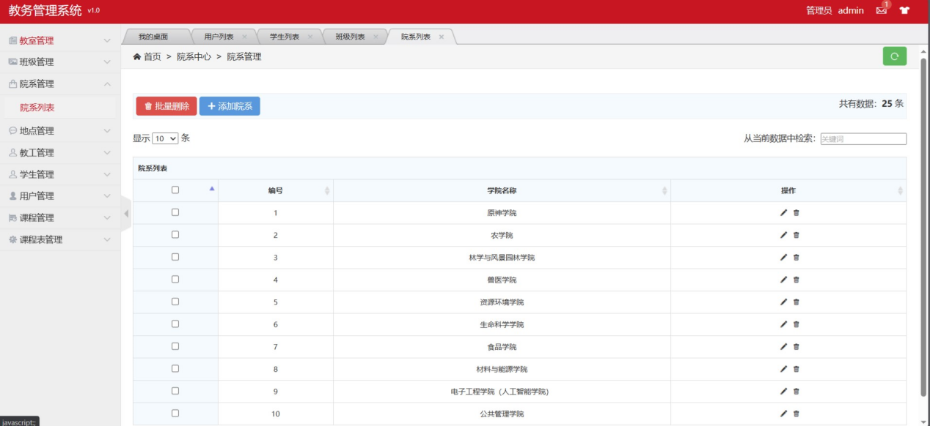

**图38 院系分页列表页面**

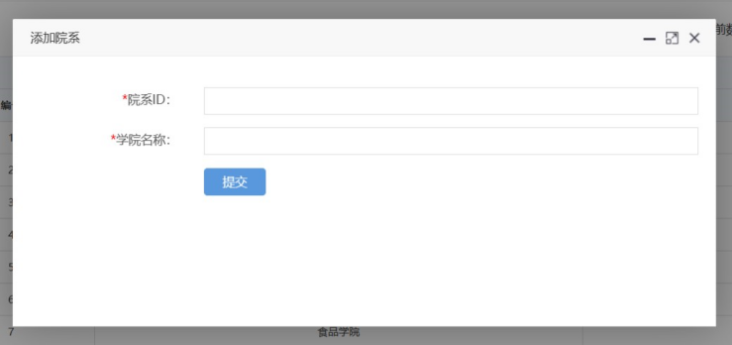

**图39 添加院系**

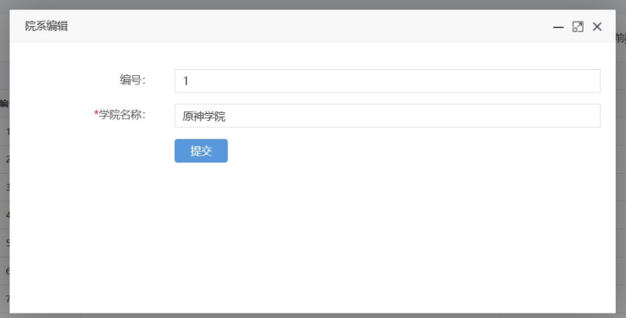

**图40 编辑院系**

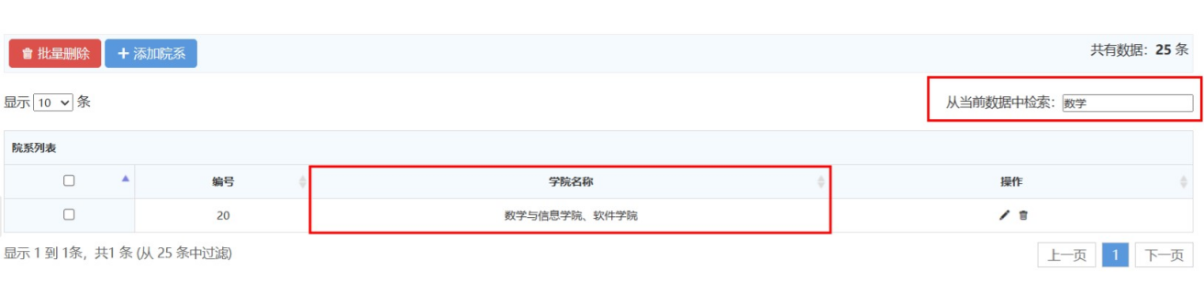

**图41 通过条件查询院系**

Faculty.java 院系实体类

@Data  
@NoArgsConstructor  
@AllArgsConstructor  
@TableName("faculty")  
public class Faculty implements Serializable {  
 @TableId  
 private Integer facultyNO; *//#院系ID* private String facultyName; *//#院系名称*}

FacultyMapper.java 院系mapper和Dao

@Repository  
public interface FacultyMapper extends BaseMapper<Faculty> {  
}

FacultyController.java 院系控制器

@Slf4j  
@Controller  
public class FacultyController {  
 @Autowired  
 private FacultyMapper facultyMapper;  
  
 @ResponseBody  
 @GetMapping("/faculty/isAvailableFacultyNO")  
 public HashMap<String, Object> isAvailableFacultyNO(Faculty faculty){  
 Faculty room = facultyMapper.selectById(faculty.getFacultyNO());  
 HashMap<String, Object> map = new HashMap<>();  
 if (room == null){  
 map.put("code","100");  
 map.put("id",faculty.getFacultyNO());  
 } else {  
 map.put("code","500");  
 map.put("id",faculty.getFacultyNO());  
 }  
 return map;  
 }  
   
 @ResponseBody  
 @GetMapping("/faculty/facultyList")  
 public List<Faculty> toFacultyList(){  
 return facultyMapper.selectList(null);  
 }  
  
 public Faculty getFacultyById(Integer id){  
 return facultyMapper.selectById(id);  
 }  
   
   
 @GetMapping("/faculty/facultyListPage")  
 public String toFacultyList(Model model){  
 List<Faculty> facultyList = facultyMapper.selectList(null);  
 model.addAttribute("facultyList",facultyList);  
 return "faculty/admin-list";  
 }  
  
 @ResponseBody  
 @PostMapping("/faculty/deleteFacultyById")  
 public HashMap<String, Object> deleteFacultyById(Faculty faculty){  
 *log*.info(faculty.toString());  
  
 int count = facultyMapper.deleteById(faculty.getFacultyNO());  
 *log*.info(String.*valueOf*(count));  
  
 HashMap<String, Object> map = new HashMap<>();  
 if (count==1){  
 map.put("code","100");  
 map.put("id",faculty.getFacultyNO());  
 } else {  
 map.put("code","500");  
 map.put("id",faculty.getFacultyNO());  
 }  
 return map;  
 }  
  
 @ResponseBody  
 @PostMapping("/faculty/deleteBatchIds")  
 public HashMap<String, Object> deleteBatchIds(String ids){  
 System.*out*.println(ids);  
  
 JSON parse = JSONUtil.*parse*(ids);  
 int count = facultyMapper.deleteBatchIds((Collection<? extends Serializable>) parse);  
 *log*.info(String.*valueOf*(count));  
 HashMap<String, Object> map = new HashMap<>();  
 if (count>=1){  
 map.put("code","100");  
 map.put("ids",ids);  
 } else {  
 map.put("code","500");  
 map.put("ids",ids);  
 }  
 return map;  
 }  
  
 @GetMapping("/faculty/facultyAdd")  
 public String toUserAdd(){  
 return "faculty/admin-add";  
 }  
  
 @ResponseBody  
 @PostMapping("/faculty/facultyAdd")  
 public HashMap<String, Object> facultyAdd(Faculty faculty){  
 *log*.info(faculty.toString());  
  
 int count = facultyMapper.insert(faculty);  
 *log*.info(String.*valueOf*(count));  
  
 HashMap<String, Object> map = new HashMap<>();  
 if (count==1){  
 map.put("code","100");  
 map.put("id",faculty.getFacultyNO());  
 } else {  
 map.put("code","500");  
 map.put("id",faculty.getFacultyNO());  
 }  
 return map;  
 }  
  
 @GetMapping("/faculty/facultyUpdate/{id}")  
 public String toFacultyUpdate(@PathVariable("id") Integer id, Model model){  
 Faculty t = facultyMapper.selectById(id);  
 model.addAttribute("faculty",t);  
 return "faculty/admin-update";  
 }  
  
 @ResponseBody  
 @PostMapping("/faculty/facultyUpdate")  
 public HashMap<String, Object> facultyUpdate(Faculty faculty){  
 *log*.info(faculty.toString());  
  
 int count = facultyMapper.updateById(faculty);  
 *log*.info(String.*valueOf*(count));  
  
 HashMap<String, Object> map = new HashMap<>();  
 if (count==1){  
 map.put("code","100");  
 map.put("id",faculty.getFacultyNO());  
 } else {  
 map.put("code","500");  
 map.put("id",faculty.getFacultyNO());  
 }  
 return map;  
 }  
}

**5.2.6地点模块**

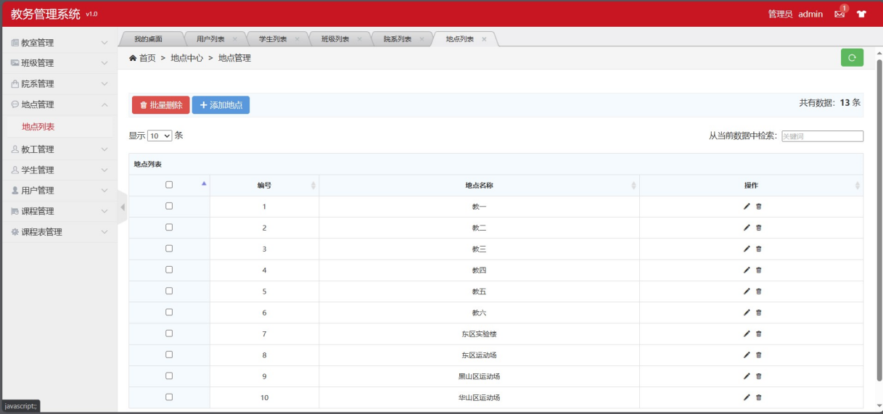

**图42 地点分页列表页面**

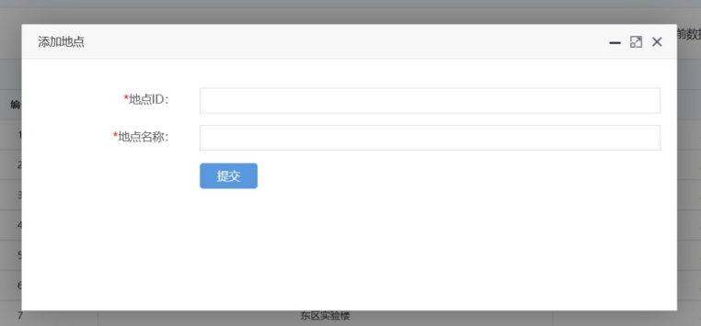

**图43 添加地点**

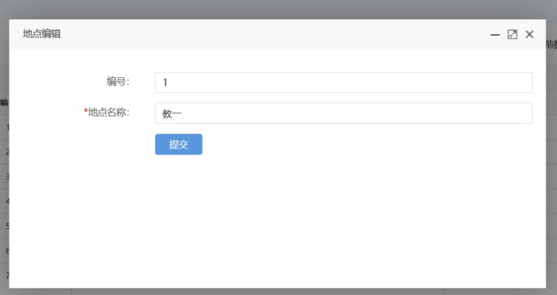

**图44 编辑地点**

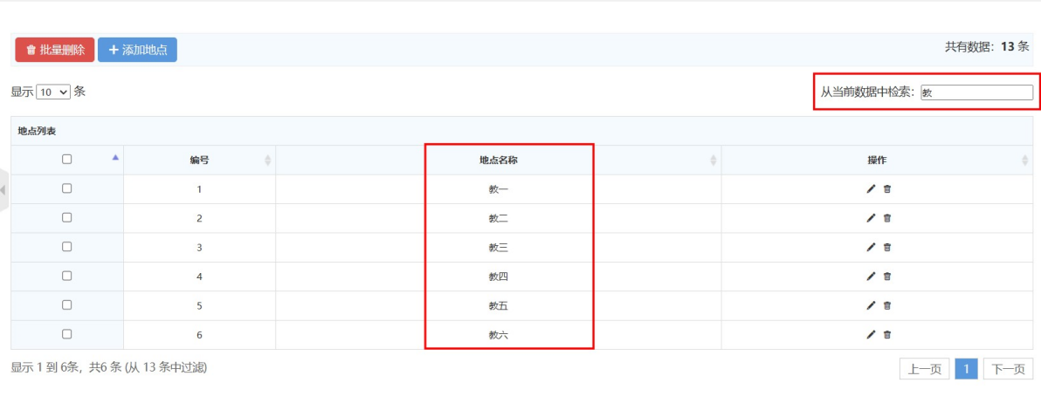

**图45 通过条件查询地点**

Location.java 地点实体类

@Data  
@NoArgsConstructor  
@AllArgsConstructor  
@TableName("location")  
public class Location implements Serializable {  
 @TableId  
 private Integer locationNo; *// 地点ID* private String locationName; *// 地点名称*}

LocationMapper.java 地点mapper和Dao

@Repository  
public interface LocationMapper extends BaseMapper<Location> {  
}

LocationController.java 地点控制器

@Slf4j  
@Controller  
public class LocationController {  
 @Autowired  
 private LocationMapper locationMapper;  
  
 @ResponseBody  
 @GetMapping("/location/isAvailableLocationNO")  
 public HashMap<String, Object> isAvailableLocationNO(Location location){  
 Location room = locationMapper.selectById(location.getLocationNo());  
 HashMap<String, Object> map = new HashMap<>();  
 if (room == null){  
 map.put("code","100");  
 map.put("id",location.getLocationNo());  
 } else {  
 map.put("code","500");  
 map.put("id",location.getLocationNo());  
 }  
 return map;  
 }  
   
 public Location getLocationById(Integer id){  
 return locationMapper.selectById(id);  
 }  
 public List<Location> locationList(){  
 return locationMapper.selectList(null);  
 }  
  
 @GetMapping("/location/locationListPage")  
 public String toLocationList(Model model){  
 List<Location> locationList = locationMapper.selectList(null);  
 model.addAttribute("locationList",locationList);  
 return "location/admin-list";  
 }  
  
 @ResponseBody  
 @PostMapping("/location/deleteLocationById")  
 public HashMap<String, Object> deleteLocationById(Location location){  
 *log*.info(location.toString());  
  
 int count = locationMapper.deleteById(location.getLocationNo());  
 *log*.info(String.*valueOf*(count));  
  
 HashMap<String, Object> map = new HashMap<>();  
 if (count==1){  
 map.put("code","100");  
 map.put("id",location.getLocationNo());  
 } else {  
 map.put("code","500");  
 map.put("id",location.getLocationNo());  
 }  
 return map;  
 }  
  
 @ResponseBody  
 @PostMapping("/location/deleteBatchIds")  
 public HashMap<String, Object> deleteBatchIds(String ids){  
 System.*out*.println(ids);  
  
 JSON parse = JSONUtil.*parse*(ids);  
 int count = locationMapper.deleteBatchIds((Collection<? extends Serializable>) parse);  
 *log*.info(String.*valueOf*(count));  
 HashMap<String, Object> map = new HashMap<>();  
 if (count>=1){  
 map.put("code","100");  
 map.put("ids",ids);  
 } else {  
 map.put("code","500");  
 map.put("ids",ids);  
 }  
 return map;  
 }  
  
 @GetMapping("/location/locationAdd")  
 public String toUserAdd(){  
 return "location/admin-add";  
 }  
  
 @ResponseBody  
 @PostMapping("/location/locationAdd")  
 public HashMap<String, Object> locationAdd(Location location){  
 *log*.info(location.toString());  
  
 int count = locationMapper.insert(location);  
 *log*.info(String.*valueOf*(count));  
  
 HashMap<String, Object> map = new HashMap<>();  
 if (count==1){  
 map.put("code","100");  
 map.put("id",location.getLocationNo());  
 } else {  
 map.put("code","500");  
 map.put("id",location.getLocationNo());  
 }  
 return map;  
 }  
  
 @GetMapping("/location/locationUpdate/{id}")  
 public String toLocationUpdate(@PathVariable("id") Integer id,Model model){  
 Location t = locationMapper.selectById(id);  
 model.addAttribute("location",t);  
 return "location/admin-update";  
 }  
  
 @ResponseBody  
 @PostMapping("/location/locationUpdate")  
 public HashMap<String, Object> locationUpdate(Location location){  
 *log*.info(location.toString());  
  
 int count = locationMapper.updateById(location);  
 *log*.info(String.*valueOf*(count));  
  
 HashMap<String, Object> map = new HashMap<>();  
 if (count==1){  
 map.put("code","100");  
 map.put("id",location.getLocationNo());  
 } else {  
 map.put("code","500");  
 map.put("id",location.getLocationNo());  
 }  
 return map;  
 }  
  
}

**5.2.7教工模块**

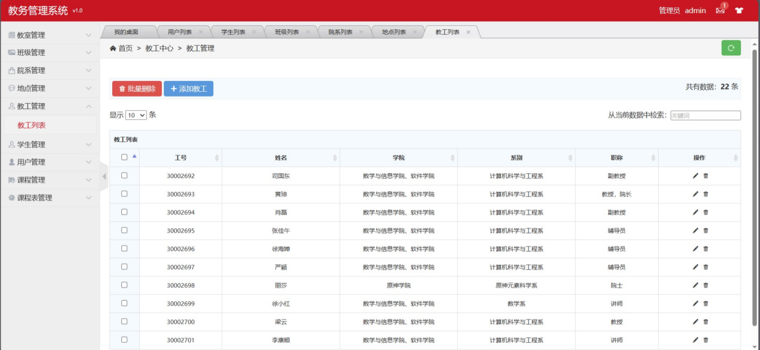

**图46 教工列表页面**

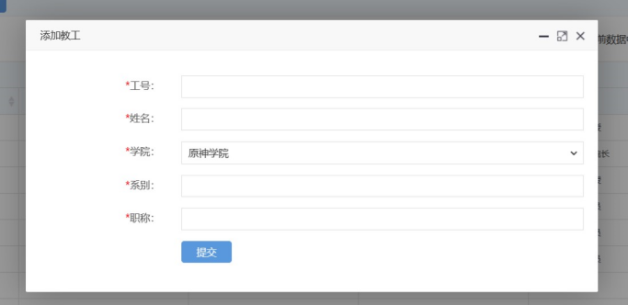

**图47 添加教工**

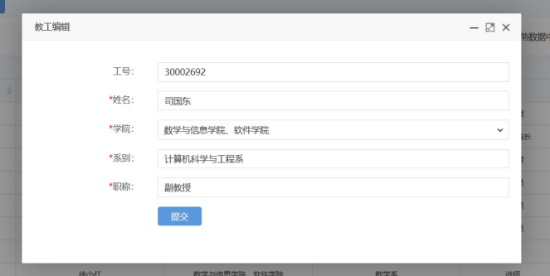

**图48 编辑教工**

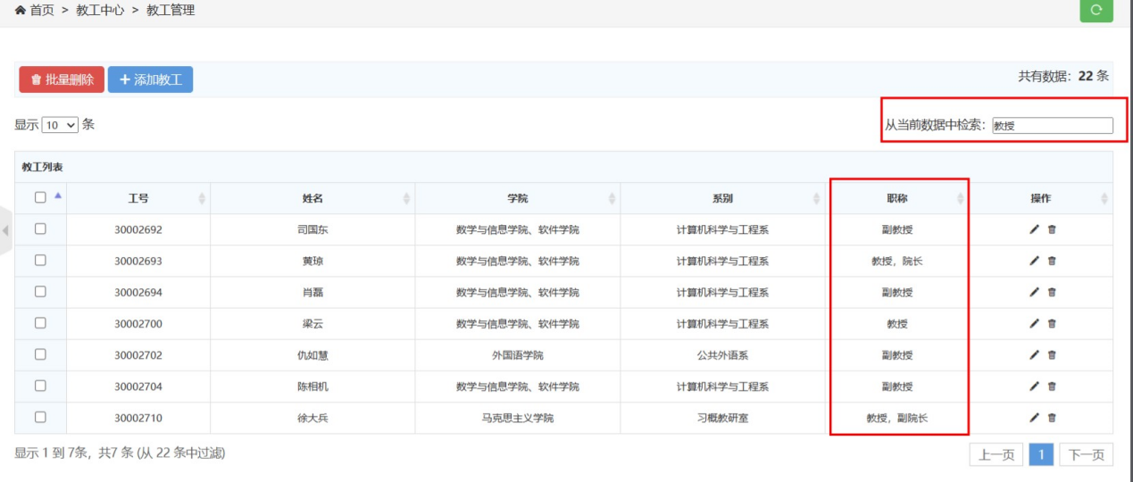

**图49 通过条件查询教工**

Teacher.java 教工实体类

@Data  
@NoArgsConstructor  
@AllArgsConstructor  
@TableName("teacher")  
public class Teacher implements Serializable {  
 @TableId  
 private Integer teacherID; *// 教工编号* private String name; *// 姓名* private Integer facultyNO; *// 院系* @TableField(exist = false)  
 private String facultyName; *//#院系名称* private String speciality; *// 专业方向* private String title; *// 职称*}

TeacherMapper.java 教工mapper和Dao

@Repository  
public interface TeacherMapper extends BaseMapper<Teacher> {  
}

TeacherController.java 教工控制器

@Slf4j  
@Controller  
public class TeacherController {  
 @Autowired  
 private TeacherMapper teacherMapper;  
  
 @Autowired  
 private FacultyController facultyController;  
  
 @ResponseBody  
 @GetMapping("/teacher/isAvailableTeacherNO")  
 public HashMap<String, Object> isAvailableTeacherNO(Teacher teacher){  
 Teacher room = teacherMapper.selectById(teacher.getTeacherID());  
 HashMap<String, Object> map = new HashMap<>();  
 if (room == null){  
 map.put("code","100");  
 map.put("id",teacher.getTeacherID());  
 } else {  
 map.put("code","500");  
 map.put("id",teacher.getTeacherID());  
 }  
 return map;  
 }  
  
 public Teacher getTeacherById(Integer id){  
 return teacherMapper.selectById(id);  
 }  
  
 public List<Teacher> teacherList(){  
 return teacherMapper.selectList(null);  
 }  
  
 @GetMapping("/teacher/teacherPage")  
 public String teacherPage(Teacher teacher,Model model){  
 ArrayList<Teacher> teachers = new ArrayList<>();  
 Teacher s = teacherMapper.selectById(teacher.getTeacherID());  
 s.setFacultyName(facultyController.getFacultyById(s.getFacultyNO()).getFacultyName());  
 teachers.add(s);  
 model.addAttribute("teacherList",teachers);  
 return "teacher/admin-list-public";  
 }  
  
 @GetMapping("/teacher/teacherListPage")  
 public String toTeacherList(Model model){  
 List<Teacher> teacherList = teacherMapper.selectList(null);  
 for (Teacher teacher : teacherList) {  
 teacher.setFacultyName(facultyController.getFacultyById(teacher.getFacultyNO()).getFacultyName());  
 }  
 model.addAttribute("teacherList",teacherList);  
 return "teacher/admin-list";  
 }  
  
 @ResponseBody  
 @PostMapping("/teacher/deleteTeacherById")  
 public HashMap<String, Object> deleteTeacherById(Teacher teacher){  
 *log*.info(teacher.toString());  
  
 int count = teacherMapper.deleteById(teacher.getTeacherID());  
 *log*.info(String.*valueOf*(count));  
  
 HashMap<String, Object> map = new HashMap<>();  
 if (count==1){  
 map.put("code","100");  
 map.put("id",teacher.getTeacherID());  
 } else {  
 map.put("code","500");  
 map.put("id",teacher.getTeacherID());  
 }  
 return map;  
 }  
  
 @ResponseBody  
 @PostMapping("/teacher/deleteBatchIds")  
 public HashMap<String, Object> deleteBatchIds(String ids){  
 System.*out*.println(ids);  
  
 JSON parse = JSONUtil.*parse*(ids);  
 int count = teacherMapper.deleteBatchIds((Collection<? extends Serializable>) parse);  
 *log*.info(String.*valueOf*(count));  
 HashMap<String, Object> map = new HashMap<>();  
 if (count>=1){  
 map.put("code","100");  
 map.put("ids",ids);  
 } else {  
 map.put("code","500");  
 map.put("ids",ids);  
 }  
 return map;  
 }  
  
 @GetMapping("/teacher/teacherAdd")  
 public String totTeacherAdd(Model model){  
 List<Faculty> facultyList = facultyController.toFacultyList();  
 model.addAttribute("facultyList",facultyList);  
 return "teacher/admin-add";  
 }  
  
 @ResponseBody  
 @PostMapping("/teacher/teacherAdd")  
 public HashMap<String, Object> teacherAdd(Teacher teacher){  
 *log*.info(teacher.toString());  
  
 int count = teacherMapper.insert(teacher);  
 *log*.info(String.*valueOf*(count));  
  
 HashMap<String, Object> map = new HashMap<>();  
 if (count==1){  
 map.put("code","100");  
 map.put("id",teacher.getTeacherID());  
 } else {  
 map.put("code","500");  
 map.put("id",teacher.getTeacherID());  
 }  
 return map;  
 }  
  
 @GetMapping("/teacher/teacherUpdate/{id}")  
 public String toTeacherUpdate(@PathVariable("id") Integer id,Model model){  
 List<Faculty> facultyList = facultyController.toFacultyList();  
 model.addAttribute("facultyList",facultyList);  
 Teacher t = teacherMapper.selectById(id);  
 model.addAttribute("teacher",t);  
 return "teacher/admin-update";  
 }  
  
 @ResponseBody  
 @PostMapping("/teacher/teacherUpdate")  
 public HashMap<String, Object> teacherUpdate(Teacher teacher){  
 *log*.info(teacher.toString());  
  
 int count = teacherMapper.updateById(teacher);  
 *log*.info(String.*valueOf*(count));  
  
 HashMap<String, Object> map = new HashMap<>();  
 if (count==1){  
 map.put("code","100");  
 map.put("id",teacher.getTeacherID());  
 } else {  
 map.put("code","500");  
 map.put("id",teacher.getTeacherID());  
 }  
 return map;  
 }  
  
}

**5.2.8用户模块**

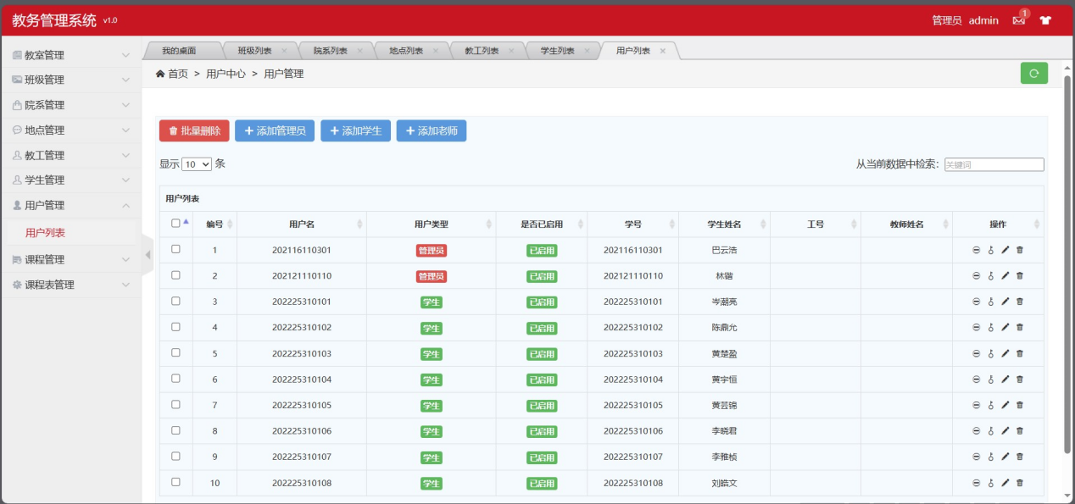

**图49 用户页面**

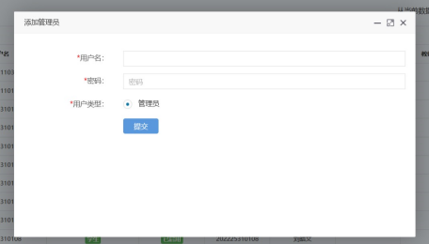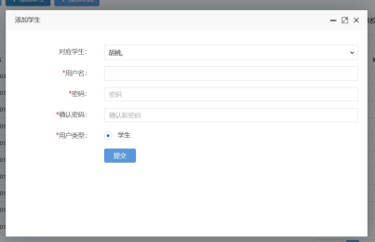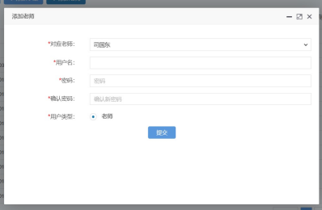

**图50 添加管理员、学生、教师用户页面**

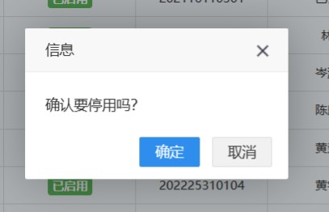 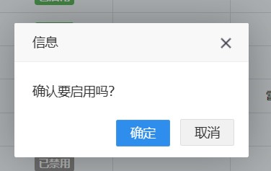

**图51 停用、启用用户页面**

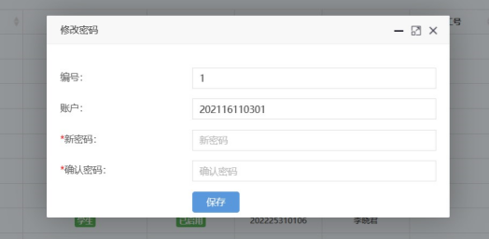

**图52 修改用户密码页面**

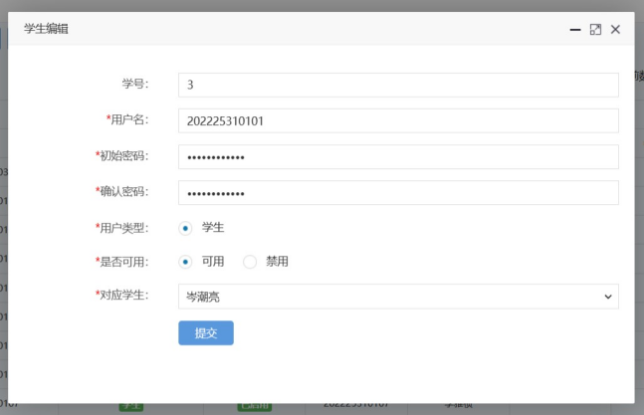

**图53 修改学生用户页面**

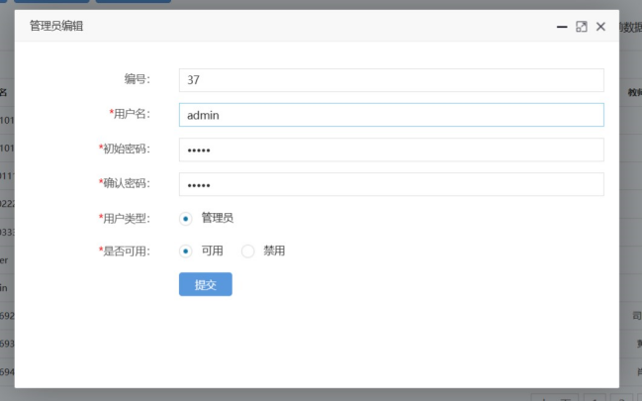

**图54 修改管理员用户页面**

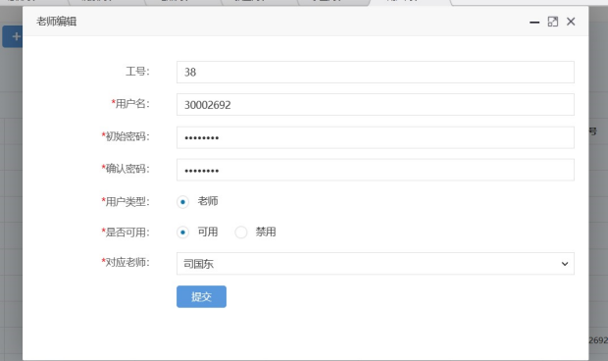

**图55 修改教师用户页面**

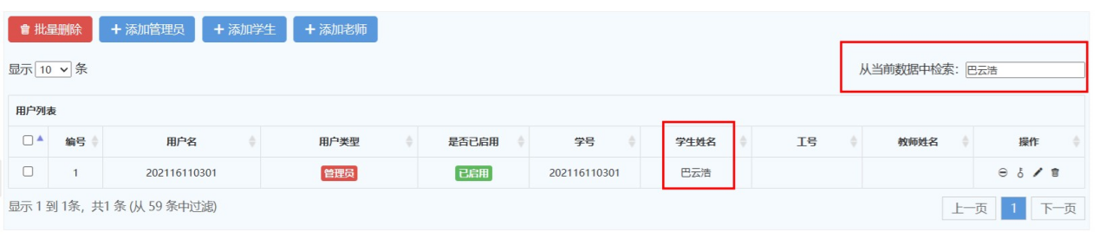

**图56 检索用户页面**

User.java 用户实体类

@Data  
@NoArgsConstructor  
@AllArgsConstructor  
@TableName("user")  
public class User implements Serializable {  
 @TableId(type = IdType.*AUTO*)  
 private String id; *//#ID* private String username; *//#用户名* private String password; *//#密码* private Integer type; *//#用户类型 0学生 1教师 2管理员* private Integer disabled; *//#是否可用  
 //TODO 更改user表的数据属性* private String contrastStudentID; *// 对应学生ID* private Integer contrastTeacherID; *// 对应老师ID* @TableField(exist = false)  
 private String contrastStudentName; *//对应学生姓名* @TableField(exist = false)  
 private String contrastTeacherName; *//对应老师姓名* @TableField(exist = false)  
 private Integer classNO; *//对应学生班级* @TableField(exist = false)  
 private String captcha; *//验证码*}

UserMapper.java 用户mapper和Dao

@Repository  
public interface UserMapper extends BaseMapper<User> {  
}

UserController.java 用户控制类类

@Slf4j  
@Controller  
public class UserController {  
 @Autowired  
 private UserMapper userMapper;  
  
 @Autowired  
 private StudentController studentController;  
  
 @Autowired  
 private TeacherController teacherController;  
  
 @ResponseBody  
 @GetMapping("/user/isAvailableUserName")  
 public HashMap<String, Object> isAvailableUserName(User useres){  
 User aUser = userMapper.selectOne(new QueryWrapper<User>().eq("username",useres.getUsername()));  
 HashMap<String, Object> map = new HashMap<>();  
 if (aUser == null){  
 map.put("code","100");  
 map.put("id",useres.getUsername());  
 } else {  
 map.put("code","500");  
 map.put("id",useres.getUsername());  
 }  
 return map;  
 }  
  
 @GetMapping("/user/userListPage")  
 public String toUserList(Model model){  
 List<User> userList = userMapper.selectList(null);  
 for (User user : userList) {  
 if (user.getContrastStudentID()!=null){  
 user.setContrastStudentName(studentController.getStudentById(user.getContrastStudentID()).getName());  
 }  
 if (user.getContrastTeacherID()!=null){  
 user.setContrastTeacherName(teacherController.getTeacherById(user.getContrastTeacherID()).getName());  
 }  
 }  
 model.addAttribute("userList",userList);  
 return "user/admin-list";  
 }  
  
 @GetMapping("/user/userPage")  
 public String userPage(User user,Model model){  
 User u = userMapper.selectOne(new QueryWrapper<User>().eq("username",user.getUsername()));  
 if (u.getContrastTeacherID()!=null){  
 Teacher teacherById = teacherController.getTeacherById(u.getContrastTeacherID());  
 u.setContrastTeacherName(teacherById.getName());  
 }  
 if (u.getContrastStudentID()!=null){  
 Student studentById = studentController.getStudentById(u.getContrastStudentID());  
 u.setContrastStudentName(studentById.getName());  
 }  
 ArrayList<User> users = new ArrayList<>();  
 users.add(u);  
 model.addAttribute("userList",users);  
 return "user/admin-list-public";  
 }  
  
 @GetMapping("/user/userListPaging/{num}/{size}")  
 @ResponseBody  
 public Page<User> pagelist(@PathVariable("num") int num, @PathVariable("size") int size){  
 QueryWrapper<User> wrapper = new QueryWrapper<>();  
 Page<User> page = new Page<>(num,size);  
 System.*out*.println(page);  
 return userMapper.selectPage(page,wrapper);  
 }  
  
 @ResponseBody  
 @PostMapping("/user/stopUserById")  
 public HashMap<String, Object> stopUserById(User user){  
 *log*.info(user.toString());  
  
 User u = new User();  
 u.setId(user.getId());  
 u.setDisabled(1);  
 int count = userMapper.updateById(u);  
 *log*.info(String.*valueOf*(count));  
  
 HashMap<String, Object> map = new HashMap<>();  
 if (count==1){  
 map.put("code","100");  
 map.put("id",user.getId());  
 } else {  
 map.put("code","500");  
 map.put("id",user.getId());  
 }  
 return map;  
 }  
  
 @ResponseBody  
 @PostMapping("/user/startUserById")  
 public HashMap<String, Object> startUserById(User user){  
 *log*.info(user.toString());  
  
 User u = new User();  
 u.setId(user.getId());  
 u.setDisabled(0);  
 int count = userMapper.updateById(u);  
 *log*.info(String.*valueOf*(count));  
  
 HashMap<String, Object> map = new HashMap<>();  
 if (count==1){  
 map.put("code","100");  
 map.put("id",user.getId());  
 } else {  
 map.put("code","500");  
 map.put("id",user.getId());  
 }  
 return map;  
 }  
  
 @ResponseBody  
 @PostMapping("/user/deleteUserById")  
 public HashMap<String, Object> deleteUserById(User user){  
 *log*.info(user.toString());  
  
 int count = userMapper.deleteById(user.getId());  
 *log*.info(String.*valueOf*(count));  
  
 HashMap<String, Object> map = new HashMap<>();  
 if (count==1){  
 map.put("code","100");  
 map.put("id",user.getId());  
 } else {  
 map.put("code","500");  
 map.put("id",user.getId());  
 }  
 return map;  
 }  
  
 @ResponseBody  
 @PostMapping("/user/deleteBatchIds")  
 public HashMap<String, Object> deleteBatchIds(String ids){  
 System.*out*.println(ids);  
  
 JSON parse = JSONUtil.*parse*(ids);  
 int count = userMapper.deleteBatchIds((Collection<? extends Serializable>) parse);  
 *log*.info(String.*valueOf*(count));  
 HashMap<String, Object> map = new HashMap<>();  
 if (count>=1){  
 map.put("code","100");  
 map.put("ids",ids);  
 } else {  
 map.put("code","500");  
 map.put("ids",ids);  
 }  
 return map;  
 }  
  
 @GetMapping("/user/userAdd")  
 public String toUserAdd(Model model){  
 List<Teacher> teachers = teacherController.teacherList();  
 model.addAttribute("teacherList",teachers);  
 List<Student> studentList = studentController.getStudentList();  
 model.addAttribute("studentList",studentList);  
 return "user/admin-add";  
 }  
  
 @GetMapping("/user/userAddStudent")  
 public String toUserAddStudent(Model model){  
 List<Student> studentList = studentController.getStudentList();  
 model.addAttribute("studentList",studentList);  
 return "user/admin-add-student";  
 }  
  
 @GetMapping("/user/userAddTeacher")  
 public String toUserAddTeacher(Model model){  
 List<Teacher> teachers = teacherController.teacherList();  
 model.addAttribute("teacherList",teachers);  
 return "user/admin-add-teacher";  
 }  
  
 @ResponseBody  
 @PostMapping("/user/userAdd")  
 public HashMap<String, Object> userAdd(User user){  
 *log*.info(user.toString());  
  
 int count = userMapper.insert(user);  
 *log*.info(String.*valueOf*(count));  
  
 HashMap<String, Object> map = new HashMap<>();  
 if (count==1){  
 map.put("code","100");  
 map.put("id",user.getId());  
 } else {  
 map.put("code","500");  
 map.put("id",user.getId());  
 }  
 return map;  
 }  
  
 @GetMapping("/user/userUpdateStudent/{id}")  
 public String userUpdateStudent(@PathVariable("id") String id,Model model){  
 User u = userMapper.selectById(id);  
 model.addAttribute("user",u);  
 List<Student> studentList = studentController.getStudentList();  
 model.addAttribute("studentList",studentList);  
 return "user/admin-update-student";  
 }  
 @GetMapping("/user/userUpdateTeacher/{id}")  
 public String userUpdateTeacher(@PathVariable("id") String id,Model model){  
 User u = userMapper.selectById(id);  
 model.addAttribute("user",u);  
 List<Teacher> teacherList = teacherController.teacherList();  
 model.addAttribute("teacherList",teacherList);  
 return "user/admin-update-teacher";  
 }  
 @GetMapping("/user/userUpdate/{id}")  
 public String toUserUpdate(@PathVariable("id") String id,Model model){  
 User u = userMapper.selectById(id);  
 model.addAttribute("user",u);  
 return "user/admin-update";  
 }  
  
 @GetMapping("/user/userUpdatePassword/{id}")  
 public String toUserUpdatePassword(@PathVariable("id") String id,Model model){  
 User u = userMapper.selectById(id);  
 model.addAttribute("user",u);  
 return "user/change-password";  
 }  
  
 @ResponseBody  
 @PostMapping("/user/userUpdate")  
 public HashMap<String, Object> userUpdate(User user){  
 *log*.info(user.toString());  
  
 int count = userMapper.updateById(user);  
 *log*.info(String.*valueOf*(count));  
  
 HashMap<String, Object> map = new HashMap<>();  
 if (count==1){  
 map.put("code","100");  
 map.put("id",user.getId());  
 } else {  
 map.put("code","500");  
 map.put("id",user.getId());  
 }  
 return map;  
 }  
  
 @ResponseBody  
 @PostMapping("/user/userUpdatePassword")  
 public HashMap<String, Object> userUpdatePassword(User user){  
 *log*.info(user.toString());  
  
 int count = userMapper.update(user,new UpdateWrapper<User>()  
 .set("password",user.getPassword())  
 .eq("id",user.getId()));  
 *log*.info(String.*valueOf*(count));  
  
 HashMap<String, Object> map = new HashMap<>();  
 if (count==1){  
 map.put("code","100");  
 map.put("id",user.getId());  
 } else {  
 map.put("code","500");  
 map.put("id",user.getId());  
 }  
 return map;  
 }  
}

**5.2.9课程模块**

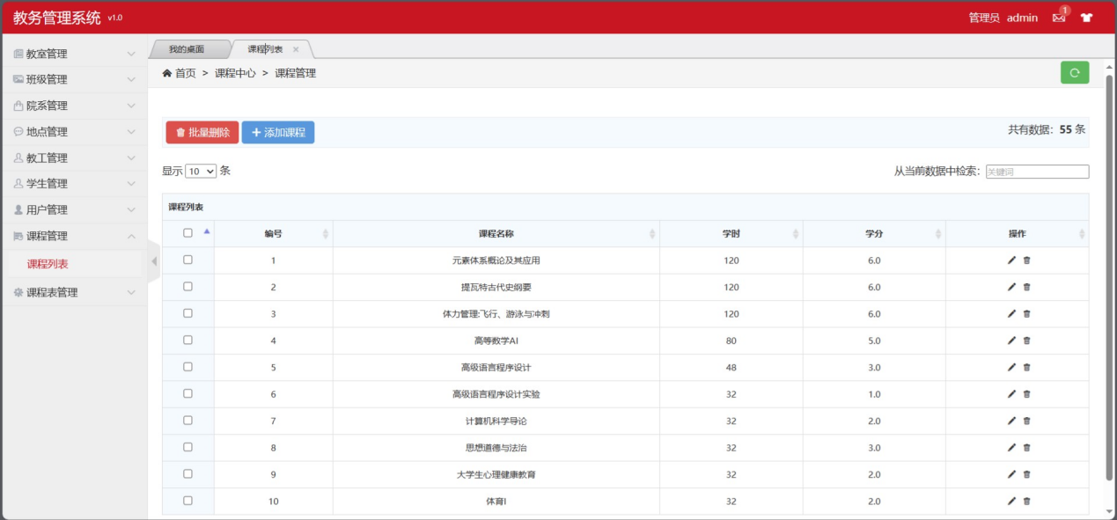

**图57 课程列表页面**

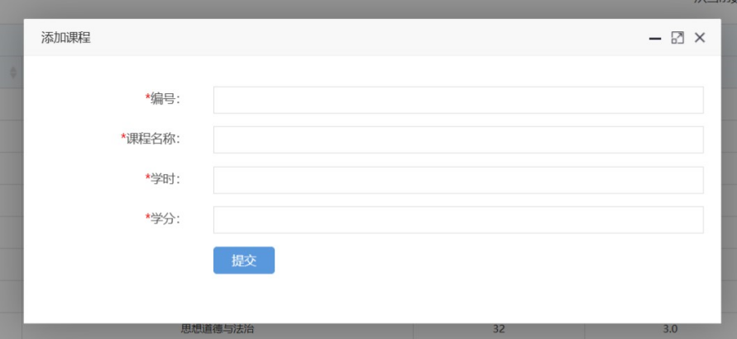

**图58 添加课程**

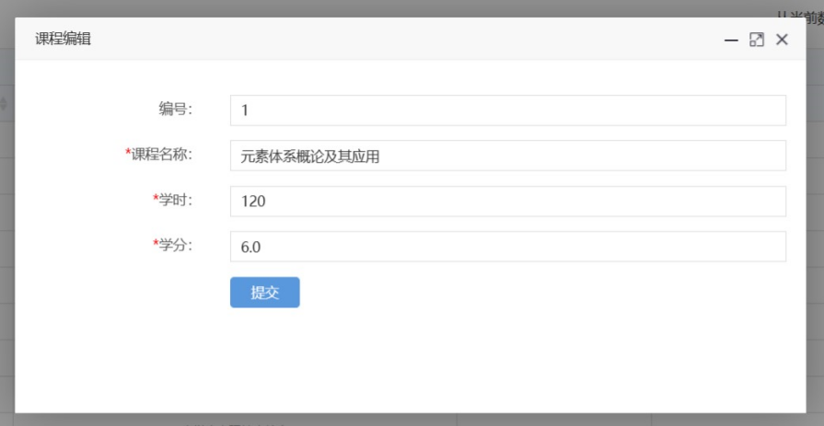

**图59 编辑课程**

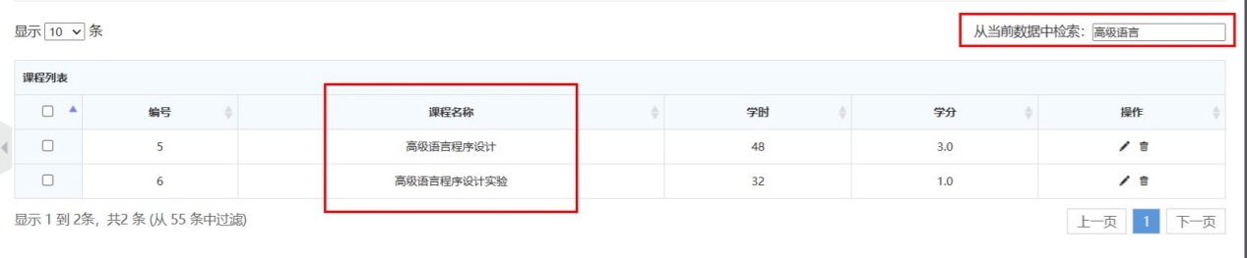

**图60 通过条件查询课程**

Course.java 课程实体类

@Data  
@NoArgsConstructor  
@AllArgsConstructor  
@TableName("course")  
public class Course implements Serializable {  
 @TableId  
 private Integer courseID; *//#课程ID* private String courseName; *//#课程名* private Integer hour; *//# 学时* private Double credit;*//# 学分*}

CourseMapper.java 课程mapper和DAO

@Repository  
public interface CourseMapper extends BaseMapper<Course> {  
}

CourseController.java 课程控制器

@Slf4j  
@Controller  
public class CourseController {  
 @Autowired  
 private CourseMapper courseMapper;  
  
 @ResponseBody  
 @GetMapping("/course/isAvailableCourseNO")  
 public HashMap<String, Object> isAvailableCourseNO(Course course){  
 Course room = courseMapper.selectById(course.getCourseID());  
 HashMap<String, Object> map = new HashMap<>();  
 if (room == null){  
 map.put("code","100");  
 map.put("id",course.getCourseID());  
 } else {  
 map.put("code","500");  
 map.put("id",course.getCourseID());  
 }  
 return map;  
 }  
   
 @ResponseBody  
 @GetMapping("/course/courseList")  
 public List<Course> toCourseList(){  
 return courseMapper.selectList(null);  
 }  
  
 public Course getCourseById(Integer id){  
 return courseMapper.selectById(id);  
 }  
   
 @GetMapping("/course/courseListPage")  
 public String toCourseList(Model model){  
 List<Course> courseList = courseMapper.selectList(null);  
 model.addAttribute("courseList",courseList);  
 return "course/admin-list";  
 }  
  
 @ResponseBody  
 @PostMapping("/course/deleteCourseById")  
 public HashMap<String, Object> deleteCourseById(Course course){  
 *log*.info(course.toString());  
  
 int count = courseMapper.deleteById(course.getCourseID());  
 *log*.info(String.*valueOf*(count));  
  
 HashMap<String, Object> map = new HashMap<>();  
 if (count==1){  
 map.put("code","100");  
 map.put("id",course.getCourseID());  
 } else {  
 map.put("code","500");  
 map.put("id",course.getCourseID());  
 }  
 return map;  
 }  
  
 @ResponseBody  
 @PostMapping("/course/deleteBatchIds")  
 public HashMap<String, Object> deleteBatchIds(String ids){  
 System.*out*.println(ids);  
  
 JSON parse = JSONUtil.*parse*(ids);  
 int count = courseMapper.deleteBatchIds((Collection<? extends Serializable>) parse);  
 *log*.info(String.*valueOf*(count));  
 HashMap<String, Object> map = new HashMap<>();  
 if (count>=1){  
 map.put("code","100");  
 map.put("ids",ids);  
 } else {  
 map.put("code","500");  
 map.put("ids",ids);  
 }  
 return map;  
 }  
  
 @GetMapping("/course/courseAdd")  
 public String toUserAdd(){  
 return "course/admin-add";  
 }  
  
 @ResponseBody  
 @PostMapping("/course/courseAdd")  
 public HashMap<String, Object> courseAdd(Course course){  
 *log*.info(course.toString());  
  
 int count = courseMapper.insert(course);  
 *log*.info(String.*valueOf*(count));  
  
 HashMap<String, Object> map = new HashMap<>();  
 if (count==1){  
 map.put("code","100");  
 map.put("id",course.getCourseID());  
 } else {  
 map.put("code","500");  
 map.put("id",course.getCourseID());  
 }  
 return map;  
 }  
  
 @GetMapping("/course/courseUpdate/{id}")  
 public String toCourseUpdate(@PathVariable("id") Integer id, Model model){  
 Course c = courseMapper.selectById(id);  
 model.addAttribute("course",c);  
 return "course/admin-update";  
 }  
  
 @ResponseBody  
 @PostMapping("/course/courseUpdate")  
 public HashMap<String, Object> courseUpdate(Course course){  
 *log*.info(course.toString());  
  
 int count = courseMapper.updateById(course);  
 *log*.info(String.*valueOf*(count));  
  
 HashMap<String, Object> map = new HashMap<>();  
 if (count==1){  
 map.put("code","100");  
 map.put("id",course.getCourseID());  
 } else {  
 map.put("code","500");  
 map.put("id",course.getCourseID());  
 }  
 return map;  
 }  
}

**5.2.10课程表模块**

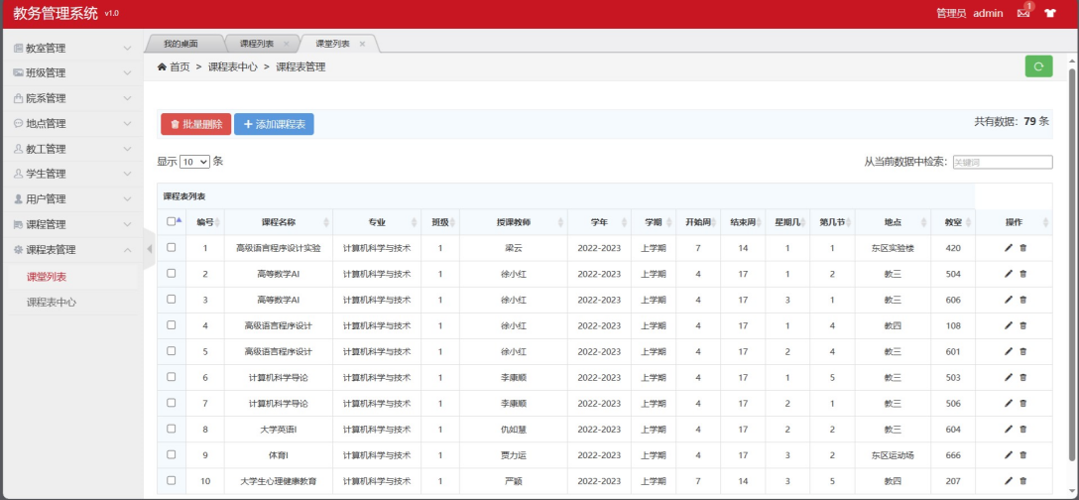

**图61 课程表列表页面**

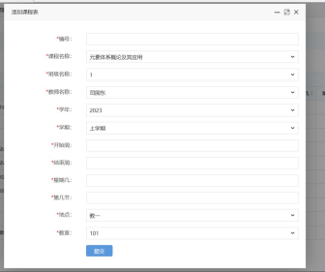

**图62 添加课程表页面**

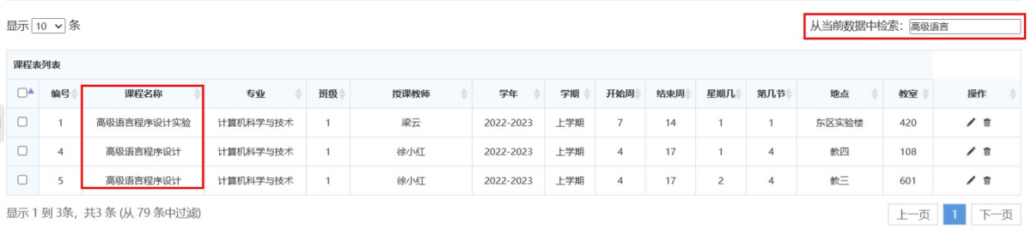

**图63 筛选课程表页面**

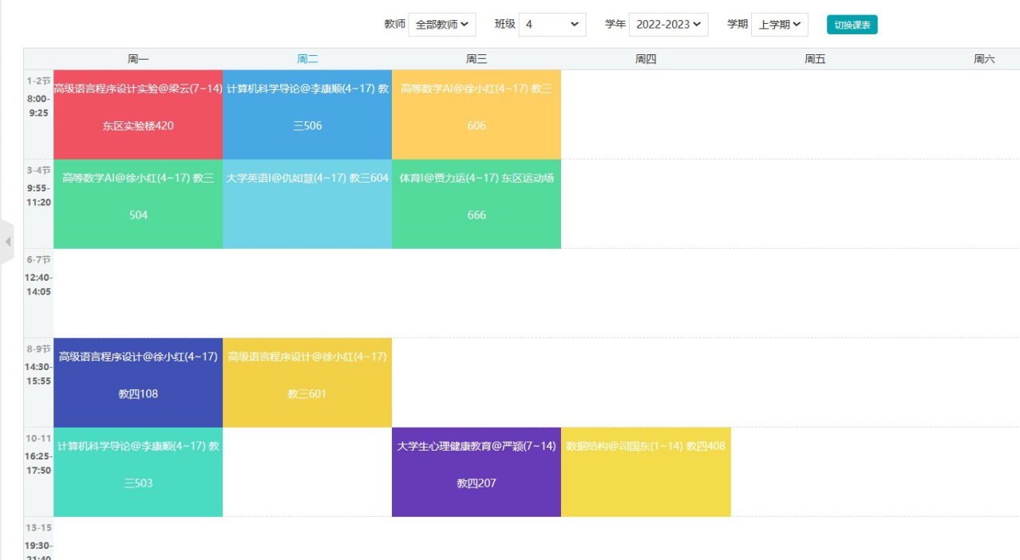

**图64 课程表页面**

Curriculum.java 课程表实体类

@Data  
@NoArgsConstructor  
@AllArgsConstructor  
@TableName("curriculum")  
public class Curriculum implements Serializable { *// 课程* @TableId  
 private Integer ID; *// 排课ID* private Integer courseNO; *// 课程号* @TableField(exist = false)  
 private String courseName; *//#课程名* private Integer classNO; *// 班级号* private Integer teacherID; *// 授课教师编号* @TableField(exist = false)  
 private String name; *// 姓名* private String schoolYear; *// 学年* private Integer term; *// 学期* private Integer startWeek; *// 第几周开始* private Integer endWeek; *// 第几周结束* private Integer weekday; *// 星期几* private Integer section; *// 第几节* private Integer locationNo; *// 地点* @TableField(exist = false)  
 private String locationName; *// 地点名称* private Integer classRoomNO; *// 教室* @TableField(exist = false)  
 private String major;  
 @TableField(exist = false)  
 private Integer classs;  
}

CurriculumMapper.java 课表Mapper和DAO

@Repository  
public interface CurriculumMapper extends BaseMapper<Curriculum> {  
}

CurriculumController.java 课程表控制器

@Slf4j  
@Controller  
public class CurriculumController {  
 @Autowired  
 private CurriculumMapper curriculumMapper;  
  
 @Autowired  
 private CourseController courseController;  
  
 @Autowired  
 private ClassController classController;  
  
 @Autowired  
 private TeacherController teacherController;  
  
 @Autowired  
 private LocationController locationController;  
  
 @Autowired  
 private ClassRoomController classRoomController;  
  
 @ResponseBody  
 @GetMapping("/curriculum/curriculumList")  
 public List<Curriculum> toCurriculumList(){  
 return curriculumMapper.selectList(null);  
 }  
  
 public Curriculum getCurriculumById(Integer id){  
 return curriculumMapper.selectById(id);  
 }  
   
   
 @GetMapping("/curriculum/curriculumListPage")  
 public String toCurriculumList(Model model){  
 List<Curriculum> curriculumList = curriculumMapper.selectList(null);  
 for (Curriculum curriculum : curriculumList) {  
 curriculum.setCourseName(courseController.getCourseById(curriculum.getCourseNO()).getCourseName());  
 curriculum.setName(teacherController.getTeacherById(curriculum.getTeacherID()).getName());  
 curriculum.setLocationName(locationController.getLocationById(curriculum.getLocationNo()).getLocationName());  
 curriculum.setMajor(classController.getClassById(curriculum.getClassNO()).getMajor());  
 curriculum.setClasss(classController.getClassById(curriculum.getClassNO()).getClasss());  
 }  
 model.addAttribute("curriculumList",curriculumList);  
 return "curriculum/admin-list";  
 }  
  
 @ResponseBody  
 @PostMapping("/curriculum/deleteCurriculumById")  
 public HashMap<String, Object> deleteCurriculumById(Curriculum curriculum){  
 *log*.info(curriculum.toString());  
  
 int count = curriculumMapper.deleteById(curriculum.getID());  
 *log*.info(String.*valueOf*(count));  
  
 HashMap<String, Object> map = new HashMap<>();  
 if (count==1){  
 map.put("code","100");  
 map.put("id",curriculum.getID());  
 } else {  
 map.put("code","500");  
 map.put("id",curriculum.getID());  
 }  
 return map;  
 }  
  
 @ResponseBody  
 @PostMapping("/curriculum/deleteBatchIds")  
 public HashMap<String, Object> deleteBatchIds(String ids){  
 System.*out*.println(ids);  
  
 JSON parse = JSONUtil.*parse*(ids);  
 int count = curriculumMapper.deleteBatchIds((Collection<? extends Serializable>) parse);  
 *log*.info(String.*valueOf*(count));  
 HashMap<String, Object> map = new HashMap<>();  
 if (count>=1){  
 map.put("code","100");  
 map.put("ids",ids);  
 } else {  
 map.put("code","500");  
 map.put("ids",ids);  
 }  
 return map;  
 }  
  
  
 @GetMapping("/curriculum/curriculumAdd")  
 public String toUserAdd(Model model){  
 List<Course> courses = courseController.toCourseList();  
 model.addAttribute("courseList",courses);  
 List<Class> classes = classController.toClassList();  
 model.addAttribute("classList",classes);  
 List<Teacher> teachers = teacherController.teacherList();  
 model.addAttribute("teacherList",teachers);  
 List<Location> locations = locationController.locationList();  
 model.addAttribute("locationList",locations);  
 List<ClassRoom> classRooms = classRoomController.toClassRoomList();  
 model.addAttribute("classRoomList",classRooms);  
 return "curriculum/admin-add";  
 }  
  
 @ResponseBody  
 @PostMapping("/curriculum/curriculumAdd")  
 public HashMap<String, Object> curriculumAdd(Curriculum curriculum){  
 *log*.info(curriculum.toString());  
  
 int count = curriculumMapper.insert(curriculum);  
 *log*.info(String.*valueOf*(count));  
  
 HashMap<String, Object> map = new HashMap<>();  
 if (count==1){  
 map.put("code","100");  
 map.put("id",curriculum.getID());  
 } else {  
 map.put("code","500");  
 map.put("id",curriculum.getID());  
 }  
 return map;  
 }  
  
 @GetMapping("/curriculum/curriculumUpdate/{id}")  
 public String toCurriculumUpdate(@PathVariable("id") Integer id, Model model){  
 List<Course> courses = courseController.toCourseList();  
 model.addAttribute("courseList",courses);  
 List<Class> classes = classController.toClassList();  
 model.addAttribute("classList",classes);  
 List<Teacher> teachers = teacherController.teacherList();  
 model.addAttribute("teacherList",teachers);  
 List<Location> locations = locationController.locationList();  
 model.addAttribute("locationList",locations);  
 List<ClassRoom> classRooms = classRoomController.toClassRoomList();  
 model.addAttribute("classRoomList",classRooms);  
 Curriculum t = curriculumMapper.selectById(id);  
 model.addAttribute("curriculum",t);  
 return "curriculum/admin-update";  
 }  
  
 @ResponseBody  
 @PostMapping("/curriculum/curriculumUpdate")  
 public HashMap<String, Object> curriculumUpdate(Curriculum curriculum){  
 *log*.info(curriculum.toString());  
  
 int count = curriculumMapper.updateById(curriculum);  
 *log*.info(String.*valueOf*(count));  
  
 HashMap<String, Object> map = new HashMap<>();  
 if (count==1){  
 map.put("code","100");  
 map.put("id",curriculum.getID());  
 } else {  
 map.put("code","500");  
 map.put("id",curriculum.getID());  
 }  
 return map;  
 }  
  
 @ResponseBody  
 @GetMapping("/curriculum/isAvailableID")  
 public HashMap<String, Object> isAvailableID(Curriculum curriculum){  
 Curriculum byId = curriculumMapper.selectById(curriculum.getID());  
 HashMap<String, Object> map = new HashMap<>();  
 if (byId == null){  
 map.put("code","100");  
 map.put("id",curriculum.getID());  
 } else {  
 map.put("code","500");  
 map.put("id",curriculum.getID());  
 }  
 return map;  
 }  
 @GetMapping("/curriculum/myCurriculumPage")  
 public String myCurriculumPage(Model model){  
 List<Curriculum> distinct_teacherID = curriculumMapper.selectList(  
 new QueryWrapper<Curriculum>()  
 .select("distinct teacherID")  
 .orderByAsc("teacherID")  
 );  
 for (Curriculum curriculum : distinct_teacherID) {  
 curriculum.setName(teacherController.getTeacherById(curriculum.getTeacherID()).getName());  
 }  
 model.addAttribute("distinctTeacherID",distinct_teacherID);  
 List<Curriculum> distinct_schoolYear = curriculumMapper.selectList(  
 new QueryWrapper<Curriculum>()  
 .select("distinct schoolYear")  
 .orderByAsc("schoolYear")  
 );  
 model.addAttribute("distinctSchoolYear",distinct_schoolYear);  
 List<Curriculum> distinct_classNO = curriculumMapper.selectList(  
 new QueryWrapper<Curriculum>()  
 .select("distinct classNO")  
 .orderByAsc("classNO")  
 );  
 model.addAttribute("distinctClassNO",distinct_classNO);  
 return "curriculum/curriculum";  
 }  
  
 @ResponseBody  
 @GetMapping("/curriculum/myCurriculum")  
 public HashMap<String, Object> myCurriculum(Curriculum curriculum){  
 *log*.info(String.*valueOf*(curriculum));  
 List<Curriculum> curriculumList = null;  
 if (curriculum.getClassNO()==404 && curriculum.getTeacherID()==404){  
 curriculumList = curriculumMapper.selectList(  
 new QueryWrapper<Curriculum>()  
 .eq("schoolYear",curriculum.getSchoolYear())  
 .eq("term",curriculum.getTerm())  
 );  
 } else if (curriculum.getClassNO()==404){  
 curriculumList = curriculumMapper.selectList(  
 new QueryWrapper<Curriculum>()  
 .eq("teacherID",curriculum.getTeacherID())  
 .eq("schoolYear",curriculum.getSchoolYear())  
 .eq("term",curriculum.getTerm())  
 );  
 } else if(curriculum.getTeacherID()==404){  
 curriculumList = curriculumMapper.selectList(  
 new QueryWrapper<Curriculum>()  
 .eq("schoolYear",curriculum.getSchoolYear())  
 .eq("term",curriculum.getTerm())  
 .eq("classNO",curriculum.getClassNO())  
 );  
 } else {  
 curriculumList = curriculumMapper.selectList(  
 new QueryWrapper<Curriculum>()  
 .eq("teacherID",curriculum.getTeacherID())  
 .eq("schoolYear",curriculum.getSchoolYear())  
 .eq("term",curriculum.getTerm())  
 .eq("classNO",curriculum.getClassNO())  
 );  
 }  
  
 HashMap<String, Object> map = new HashMap<>();  
 if (curriculumList.size() > 0){  
 map.put("code","100");  
 for (Curriculum c : curriculumList) {  
 c.setCourseName(courseController.getCourseById(c.getCourseNO()).getCourseName());  
 c.setName(teacherController.getTeacherById(c.getTeacherID()).getName());  
 c.setLocationName(locationController.getLocationById(c.getLocationNo()).getLocationName());  
 }  
 map.put("curriculumList",curriculumList);  
 } else {  
 map.put("code","500");  
 map.put("id",curriculum.getID());  
 }  
 return map;  
 }  
}

**六、总结**

通过实现本作品，学会使用SSM框架搭建一个前后端分离的WEB项目，并且能够把mybatis-plus、thymeleaf、springMVC、druid、lombok、hutool整合进入SSM框架中。在项目中能够使用基于注解的开发模式，减少代码冗余，提到代码复用性。在项目中我使用实体类接收前台传送过来的数据，springMVC自动为我们封装数据，简化开发步骤。在课程表模块中，我们使用SpringMVC的@ResponseBody注解返回给前台JOSN数据并产生课表。还能够使用拦截器对未登录的请求进行拦截，未登录就直接跳转登录页面。并且还对用户的权限进行判断，数据表user中的type字段为权限字段（0学生 1老师 2管理员），管理员用户的权限最大，能够对所有的表进行增删改查，并且能够给课表进行排课，能查询所有学年学期、所有老师、所有班级的课表，学生和老师的权限最小，只能够修改自己的密码和基础的个人信息，并查询自己的课程表，每个用户登录之后的界面不同。

同时小组成员密切合作，培养了与他人团结协作的能力，主要通过git作为项目管理工具进行协作管理。通过这次课设学习到了包括布局管理、图形界面设计、事件处理、控件使用等方面的知识。共同解决了项目中的技术问题和业务需求，这对未来参与团队项目和与他人合作都是非常有价值的。通过这次课设解决问题的能力也得到了提升，在写课设过程中，遇到了很多技术和业务上的困难，如数据库连接池性能问题、前后端交互问题等。